**ONLINE MOBILE RECHARGE SYSTEM**

**FINAL PROJECT**

**[ASP.NET CORE 2.1 - WEB API /ANGULAR 10 / BOOTSTRAP/ MATERIAL DESIGNS/**

**JWT/ ENTITY FRAMEWORK /**

**SQL SERVER]**

**Submitted By:**

**Naveeth Z A**

**Rajagurunathan Manikandan**

**Saravana Kumar B**



November - 2020

**PROJECT DESCRIPTION**

**Project Title :** Online Mobile Recharge System

**Abstract :** This System provides prepaid recharge of many network operators as well as all kind of recharge are possible. This System will provide facility for customer to recharge mobile at anytime from anywhere. This System keeps the history of the past recharges. The user has to register himself.

**Type of Project:** Web API Application

**Technology :** ASP.Net Core 2.1– Web API, Angular 10, Bootstrap, Material Designs, JWT, Entity Framework

**Tools :** Visual Studio, Visual Studio code, Postman.

**Database :** MS SQL-Server

**Our Web Application Name**:

**PAY**

***A Payments App built for India, by Indians***

**DESCRIPTION:**

The proposed project for recharging mobiles online is a web application developed to automate the mobile recharging process. It roots out the manual card system of recharge and introduces a new and genuine online recharge process. It can be used by costumer of any telecommunication company from anywhere.

The online mobile recharge system is beneficial to both the admins and users. Using the online application, the admin can add new tariff plans and update or modify the existing tariff plans. It helps the users in creating their account, and then recharging the mobiles phones at any time.

**OBJECTIVE:**

Online Mobile Recharge is a web-based application developed in .NET & Angular 10 to recharge mobile phones. The project focuses at providing an easy and reliable platform to recharge mobile of any telecommunication company through online without buying recharge card. The registered users of the system can recharge their prepaid mobile phones from anywhere at any time. The proposed project for recharging mobiles developed to automate the mobile recharging process. It roots out the manual card system of recharge and introduces a new and genuine online recharge process. The online mobile recharge system is beneficial to both the admins and users. Using the online application, the admin can add new operators, tariff plans, offers and update or modify the existing tariff plans. It helps the users in creating their account, and then recharging the mobiles phones at any time.

**PROJECT DEMO**

**Type of Users:**

1. User / Customer
2. Admin (Jolo API)

**Project Flow:**

* **User Functionalities:**

1. Signup: User will enter personal & mobile network details
2. Login: Authentication
3. User Home: Users can view recharge plans and various network operator details.
4. Recharge: Users can view recharge plans and perform recharge based on network operator and plan type.
5. My Wallet: Users can add money to their wallet using various payment modes through razor pay payment gateway with SMS authentication. The newly added money will get displayed in my wallet transaction history.
6. Operator Finder: Users can able to view mobile network operators name according to the entered mobile number.
7. My Profile: User can update their personal and mobile network details.
8. Customer Support (Chatbot service): Customer support is achieved through chatbot, which helps the user to solve their queries and book an appointment to contact our support team.
9. Logout: Logout from the application

* **Admin (Jolo API) Functionalities:**

1. Login: Authentication
2. Dashboard (Home): Admin can view transaction count, commission earnings in different visualization format such as pie chart, bar graph and generate reports in pdf format based on the dates filtered.
3. Transactions: Admin can view, update, delete both the success and failed transactions in same page. He can also filter those data based on date & store it in pdf format.
4. Statement: Admin can able to make a monthly statement on user’s earnings based on the tarrif plans.
5. Audit: Admin can view, update, delete and search the commission amount details based on the tarrif plans.

1. Logout: Logout from the application

**DATABASE DESIGN**

**Entity Relationship Diagram:**

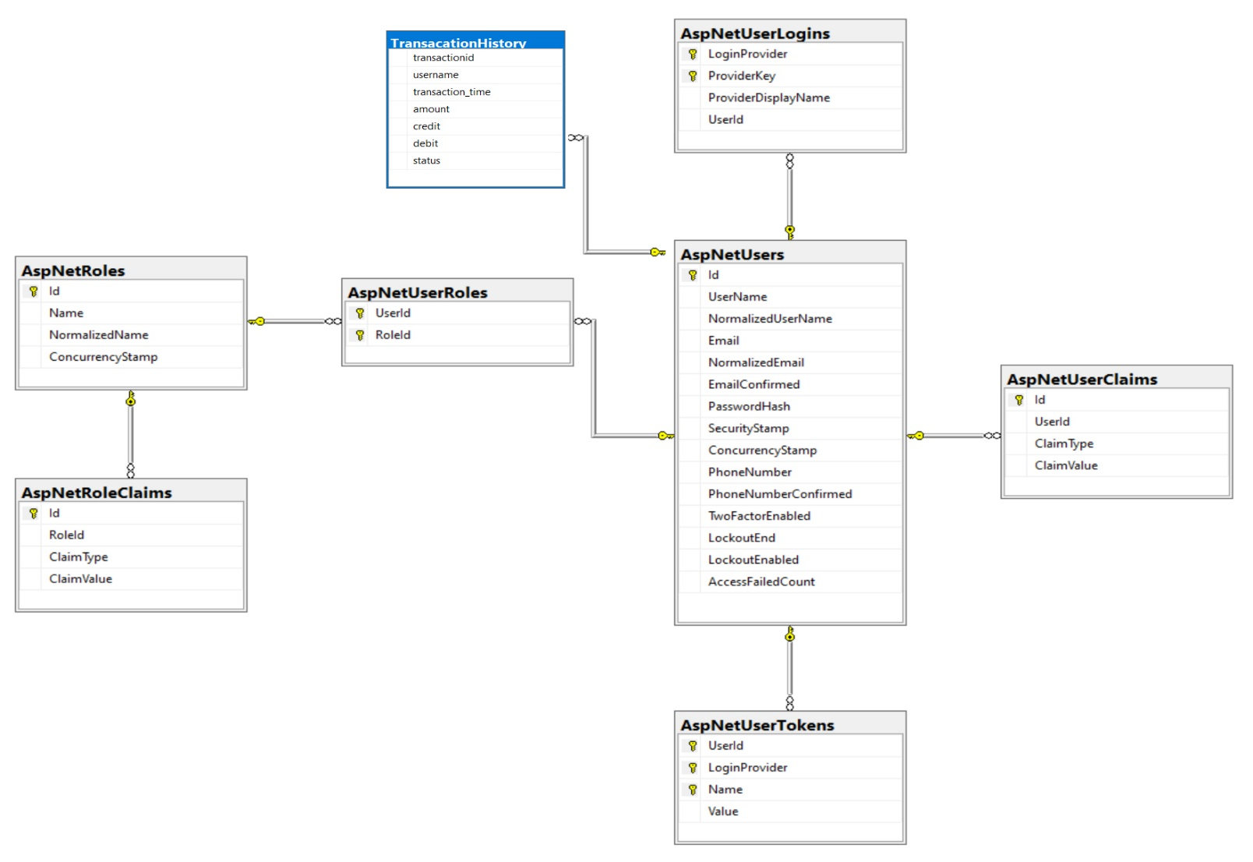

**Table Schema Diagram:**

**TABLE 1: Users**

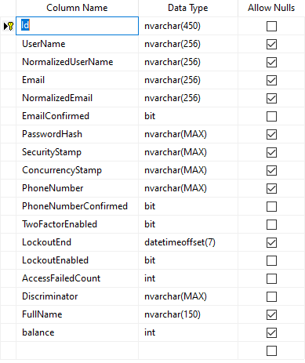

**TABLE 2: User Login**

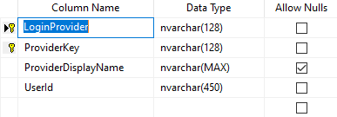

**TABLE 3: User Tokens**

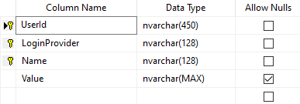

**TABLE 4: User Roles**

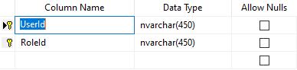

**TABLE 5: User Claims**

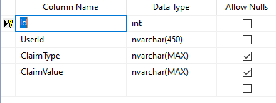

**TABLE 6: Transactions**

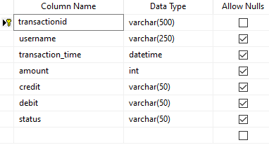

**SOURCE CODE**

**ANGULAR 10 CODE**

**UserService.ts**

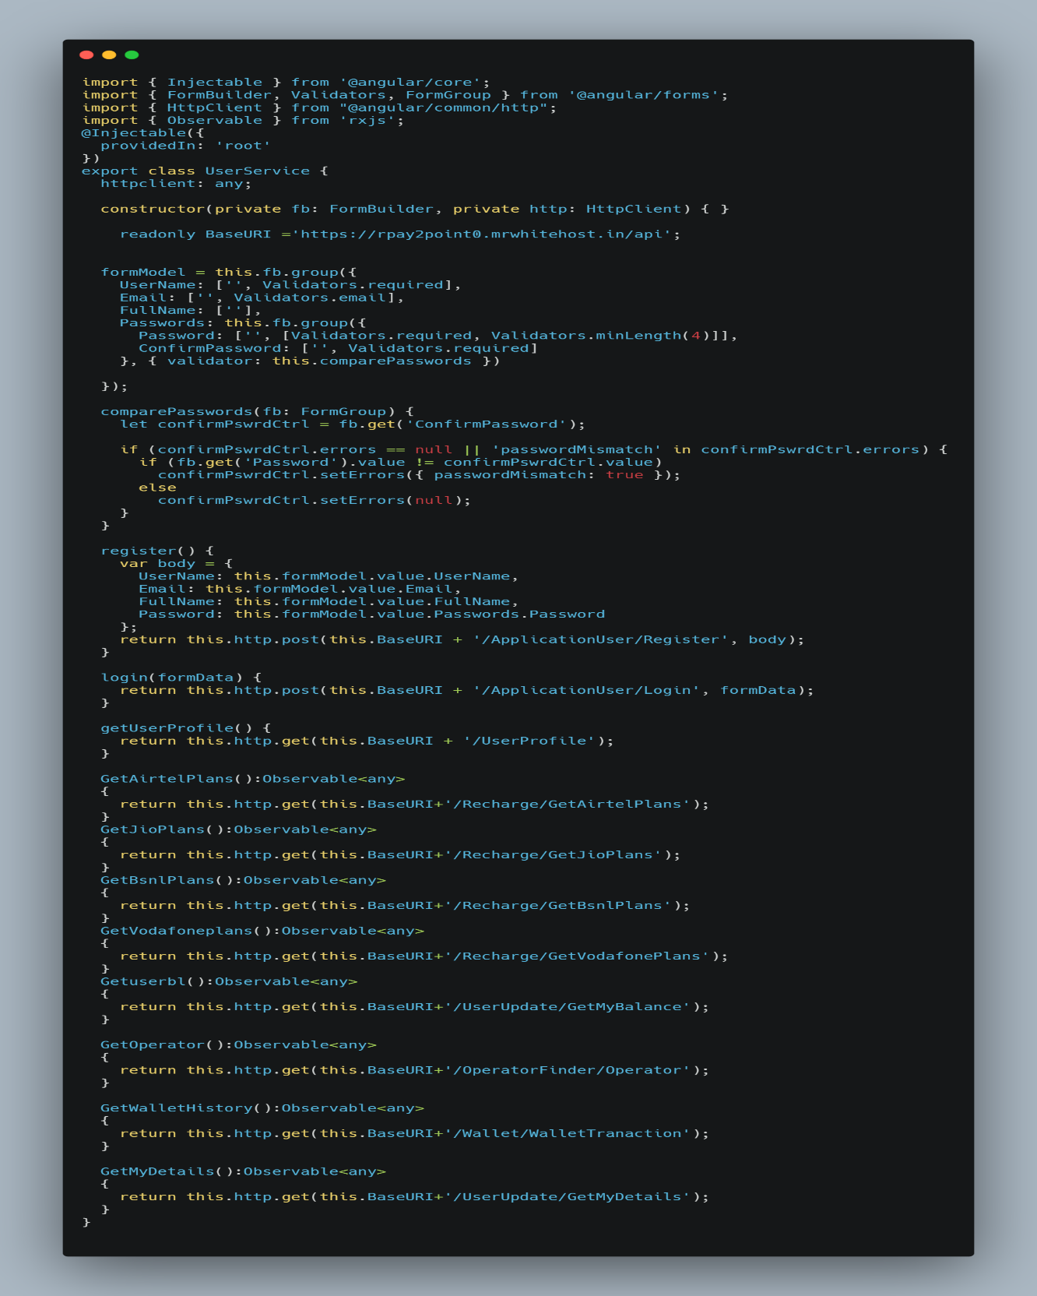

**Login.ts**

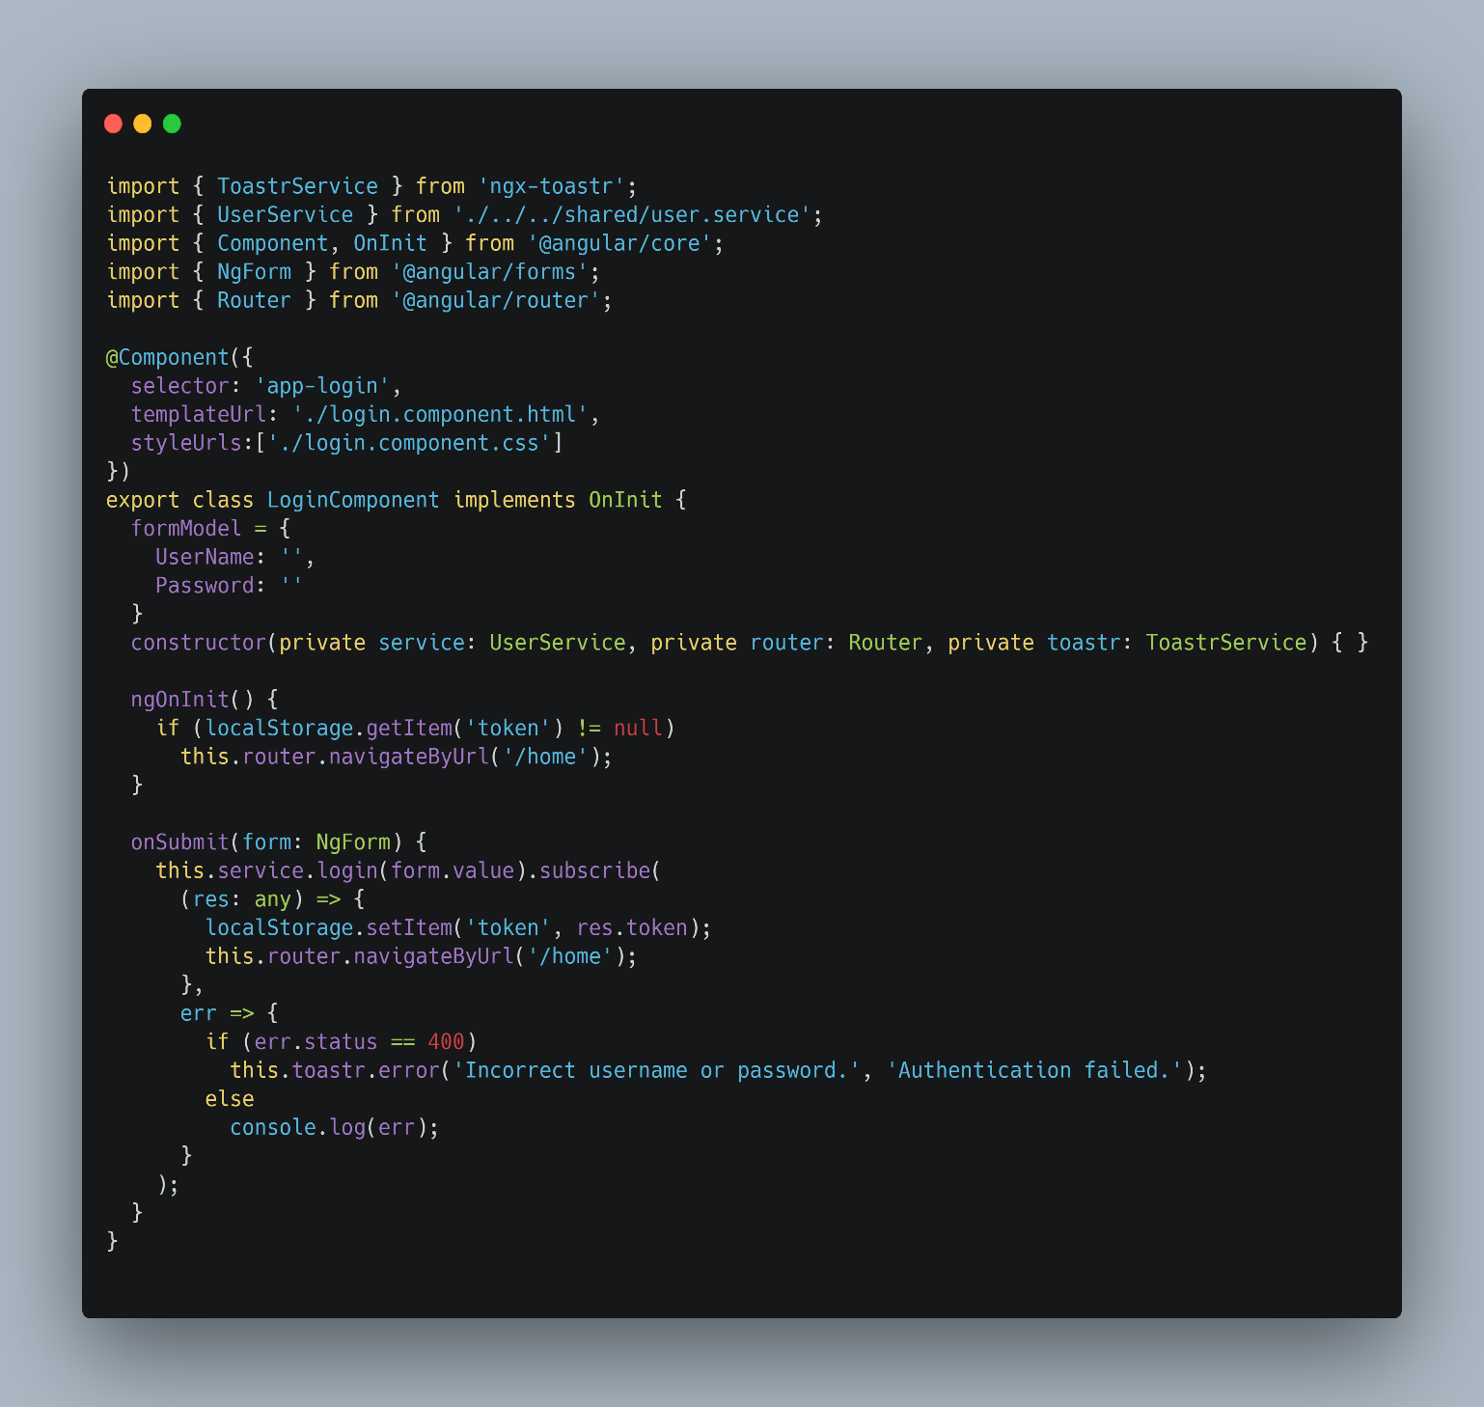

**Auth.guard.ts**

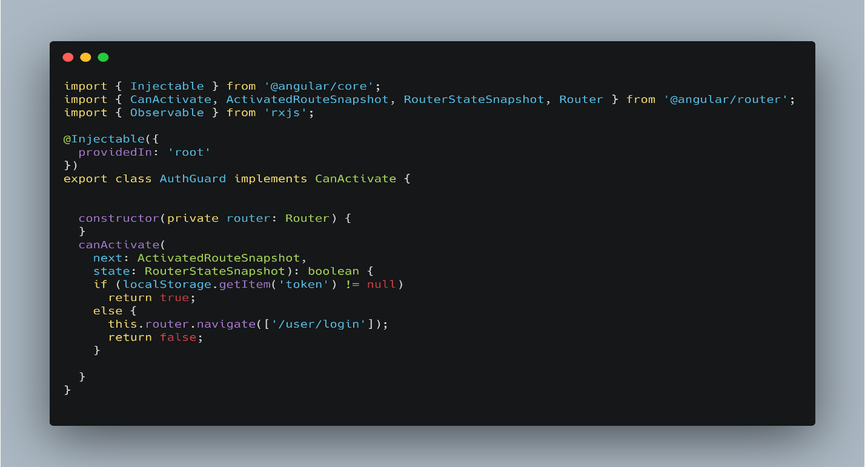

**Interceptor.ts**

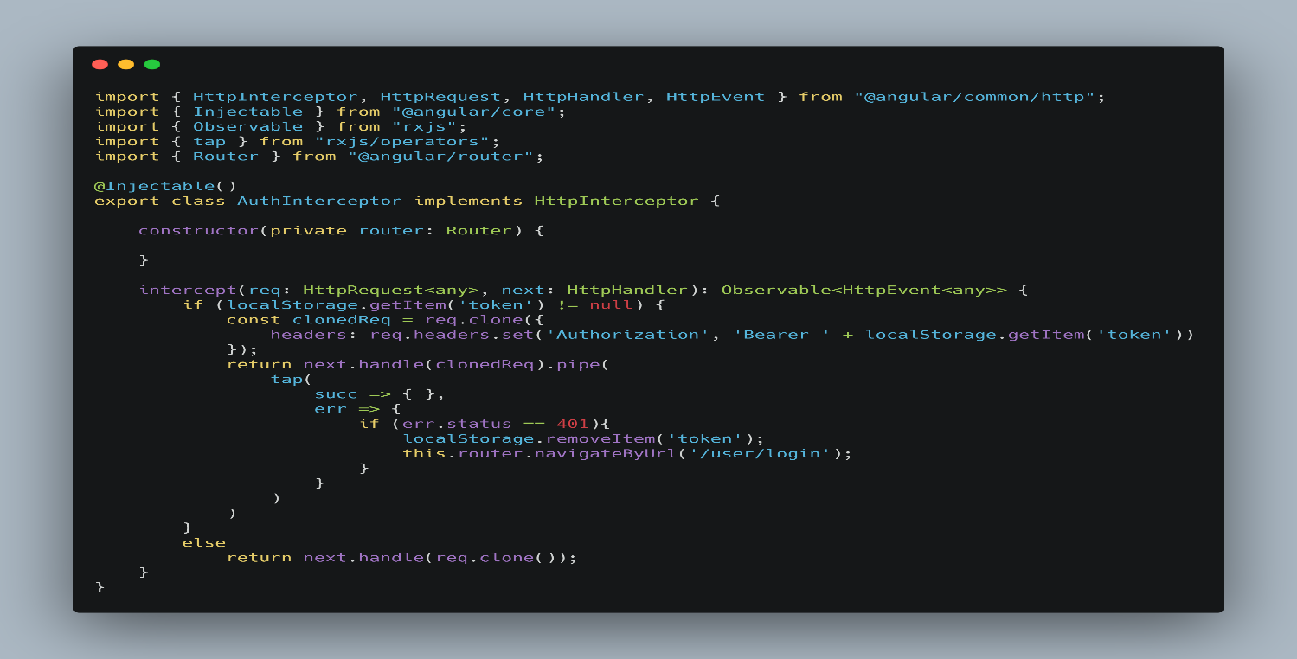

**Operator Finder.ts**

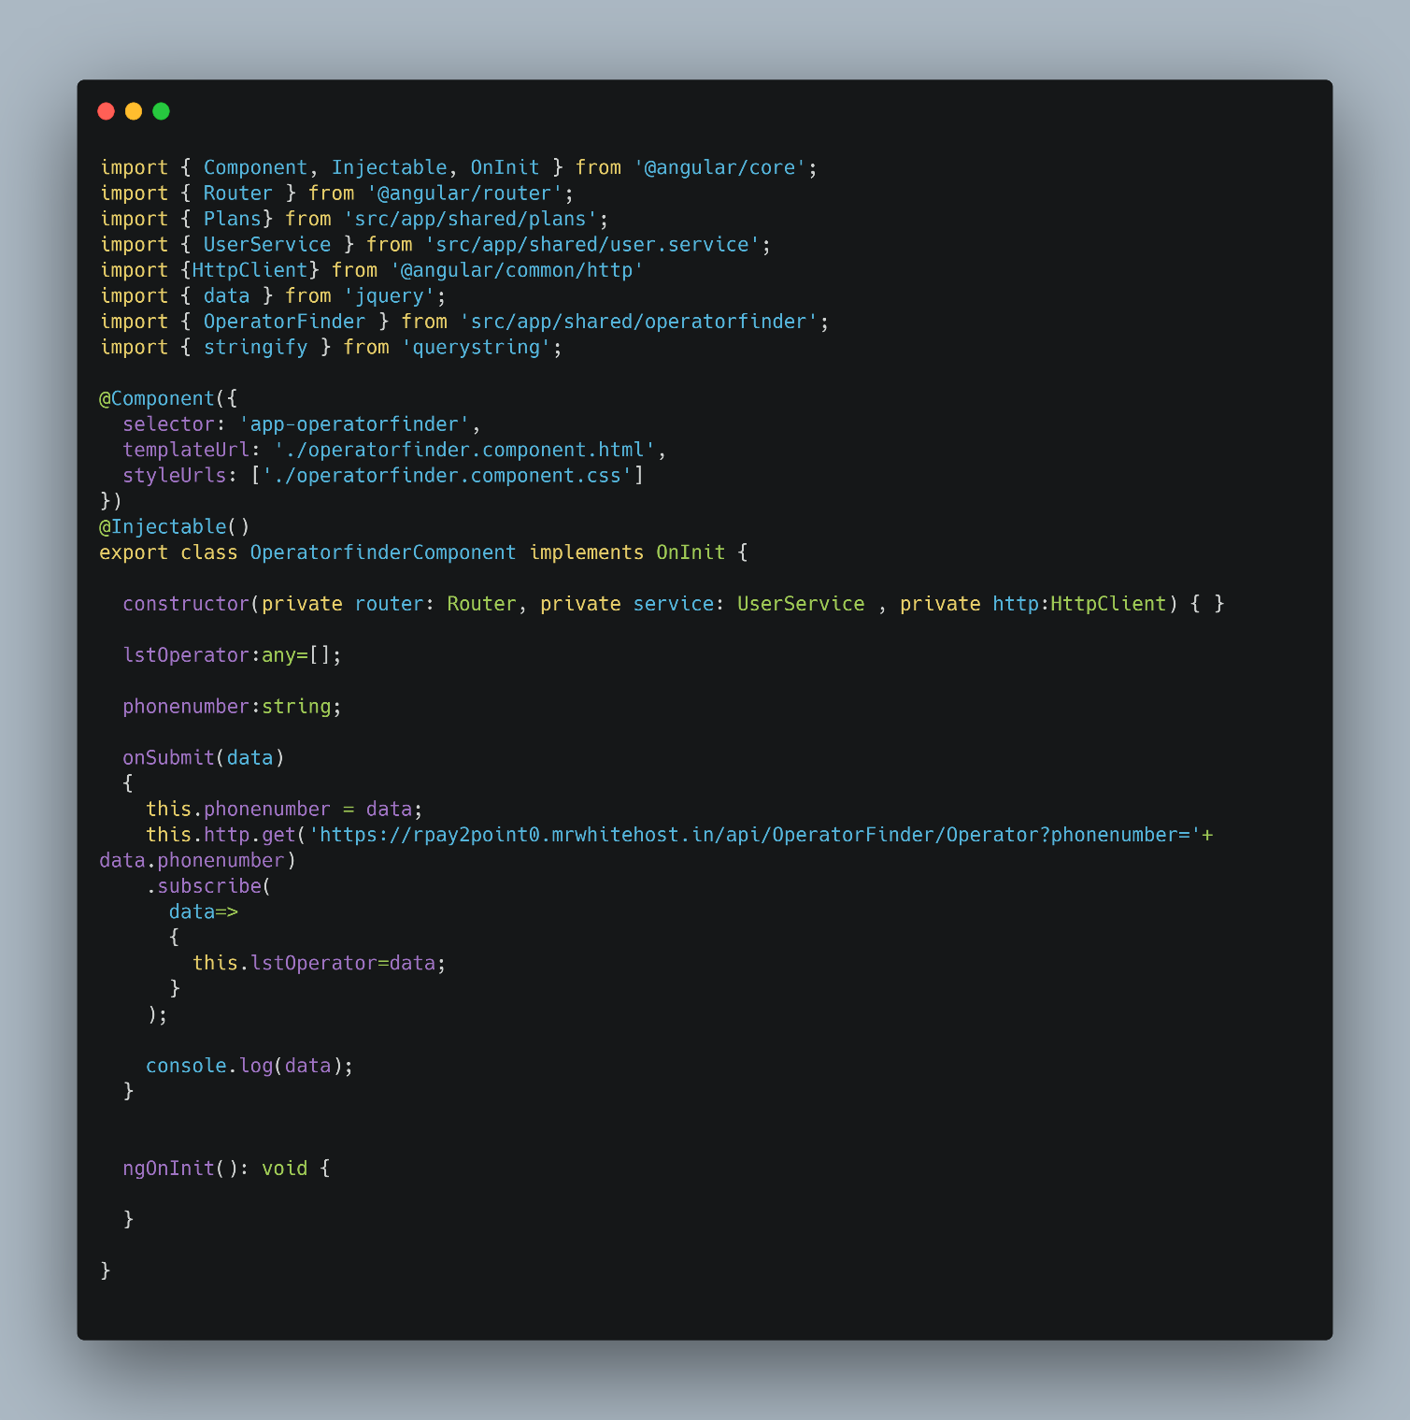

**Recharge.ts**

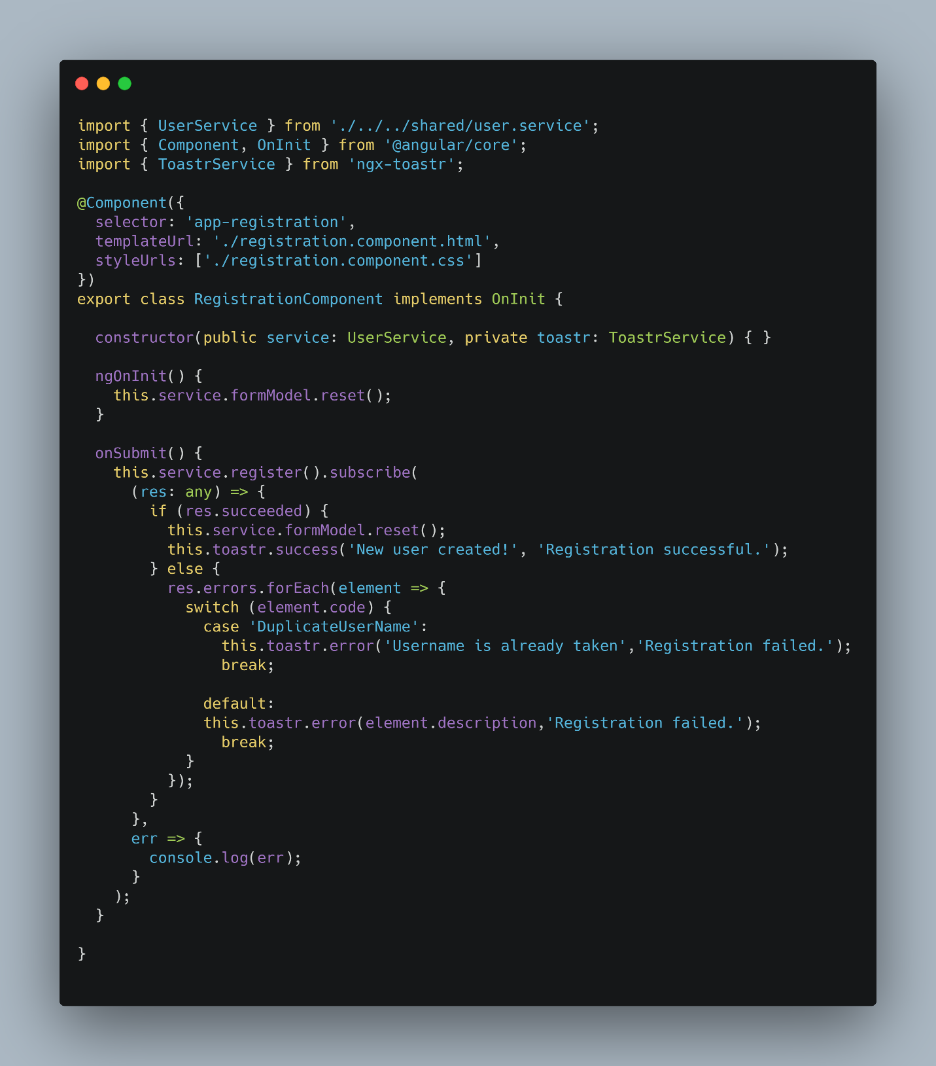

**Mywallet.ts**

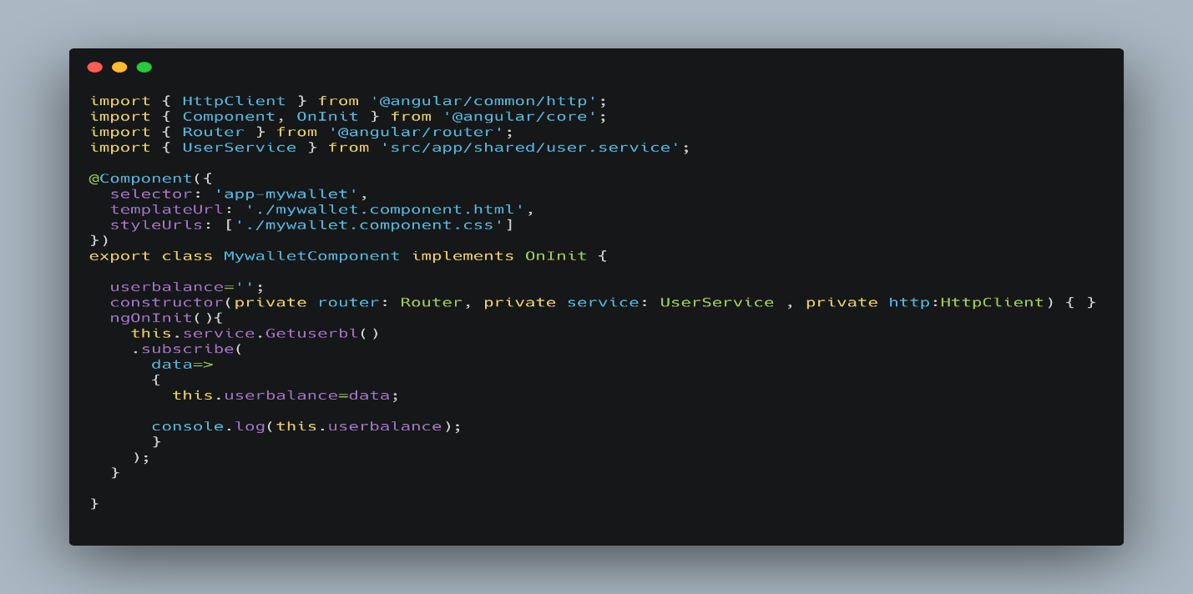

**Wallet History.ts**

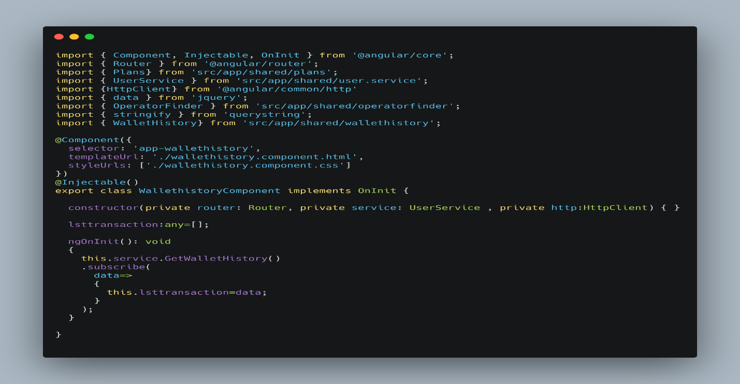

**UserUpdate.ts**

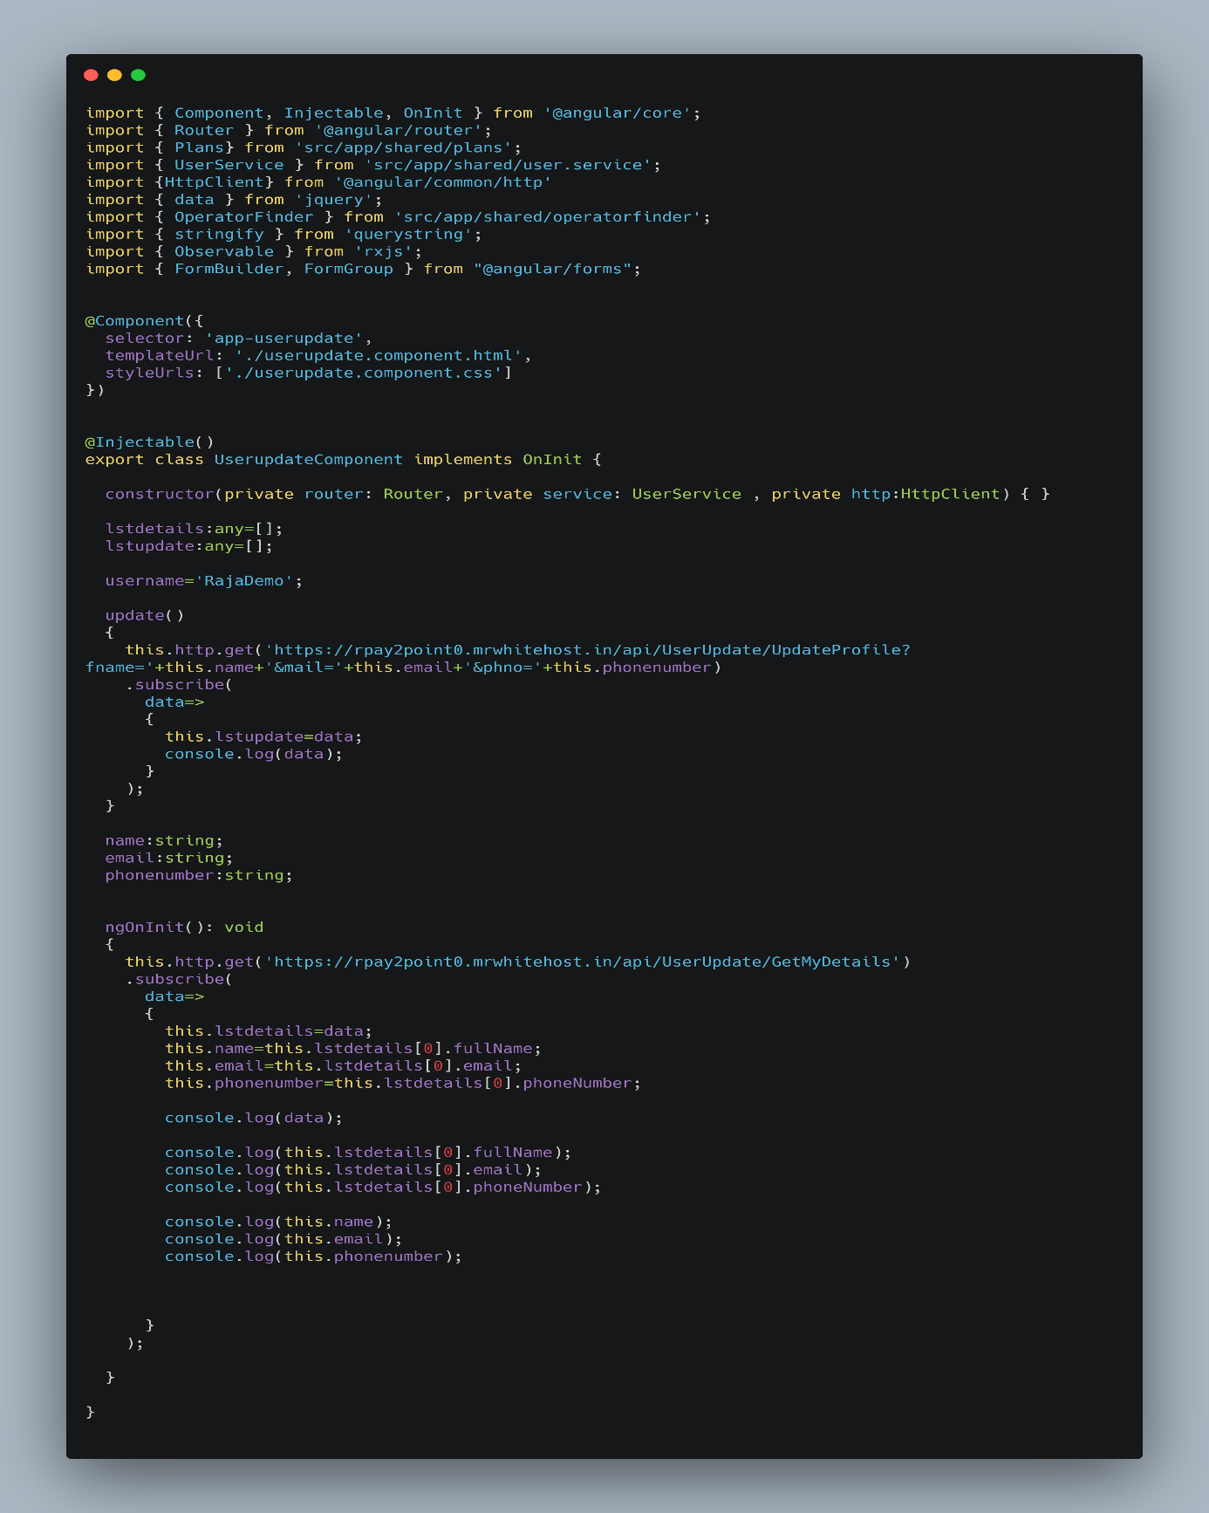

**App Routing Module.ts**

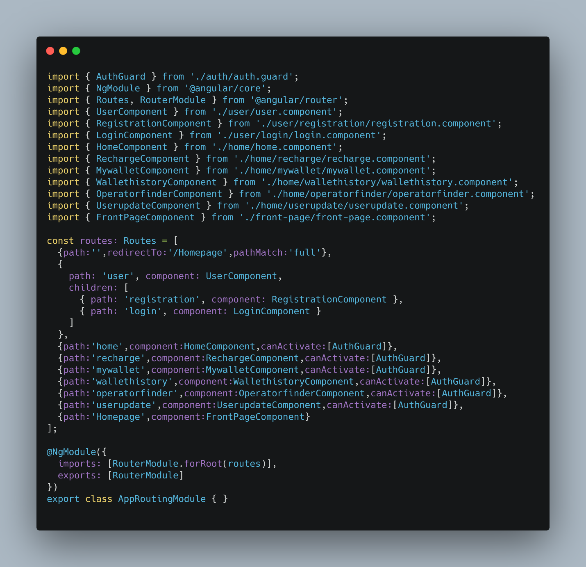

**.NET CORE 2.1 WEB API CODES:**

**Application User Controller**

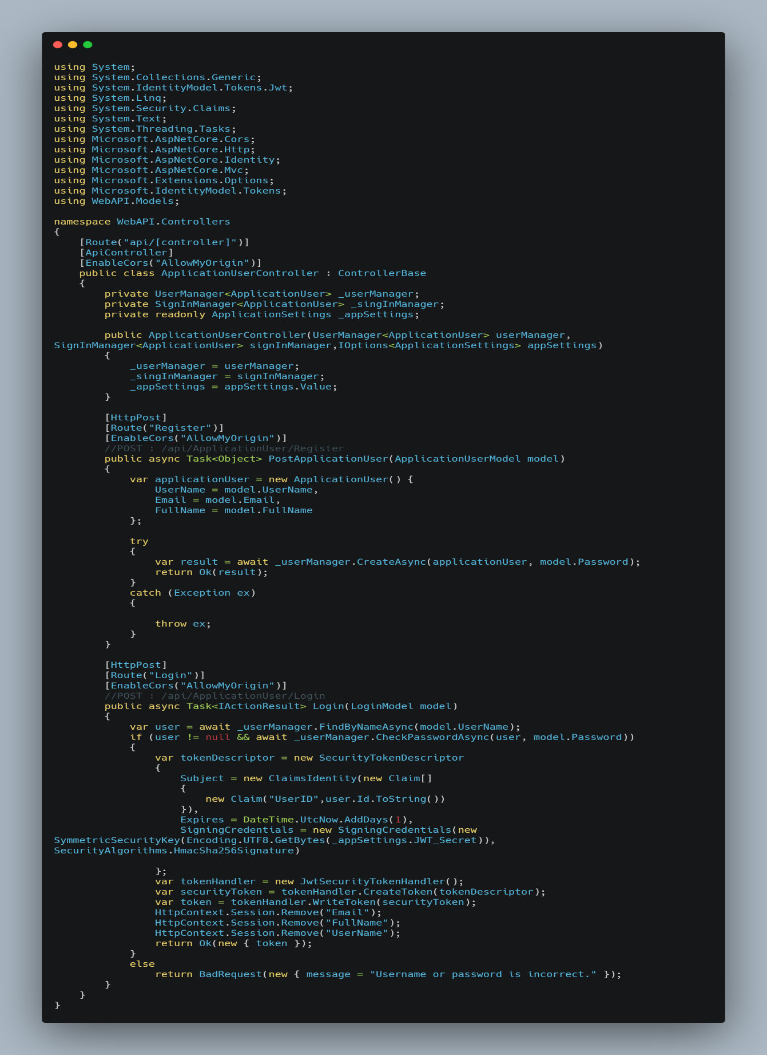

**Recharge Controller**

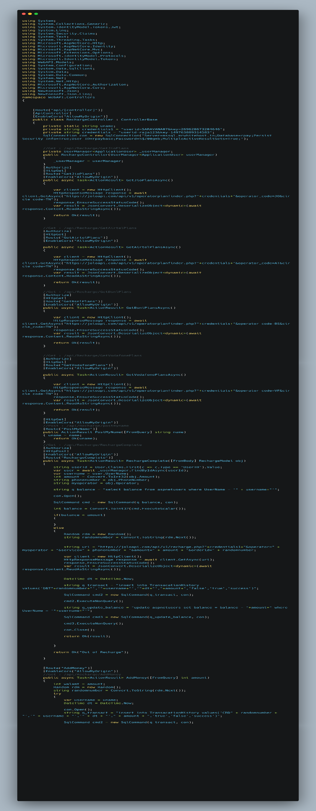

**Wallet Controller**

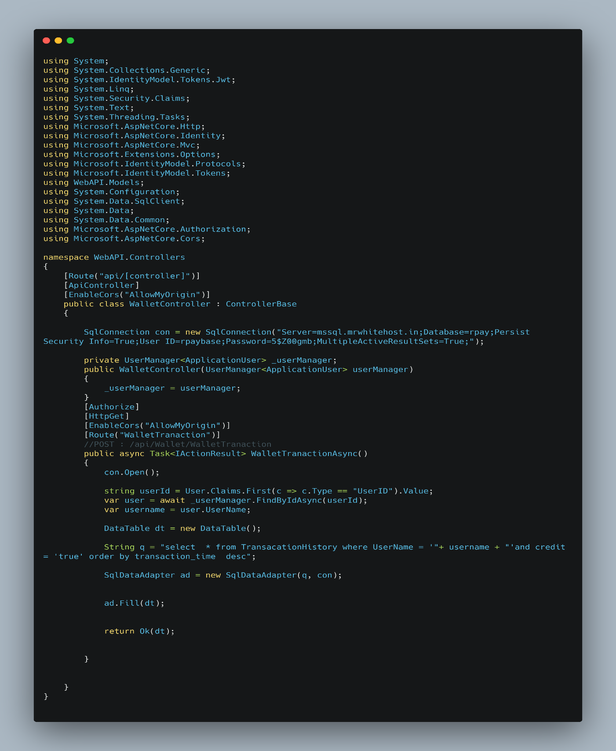

**Operator Finder Controller**

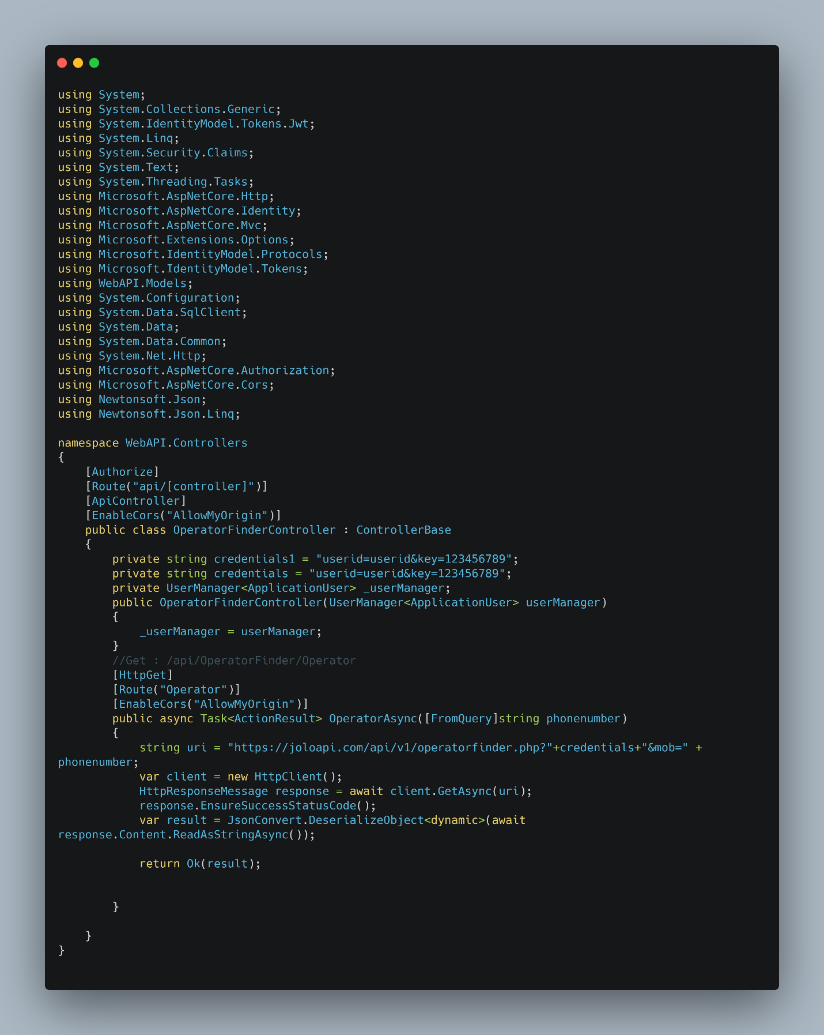

**User Update Controller**

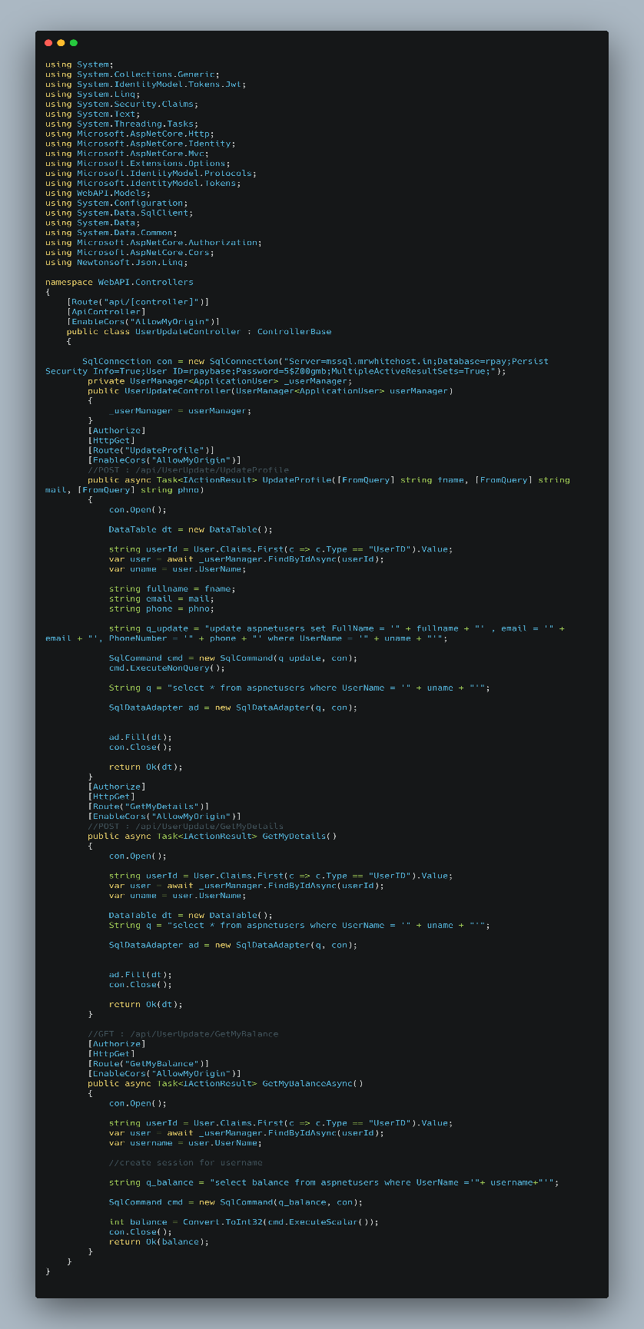

**Startup.cs**

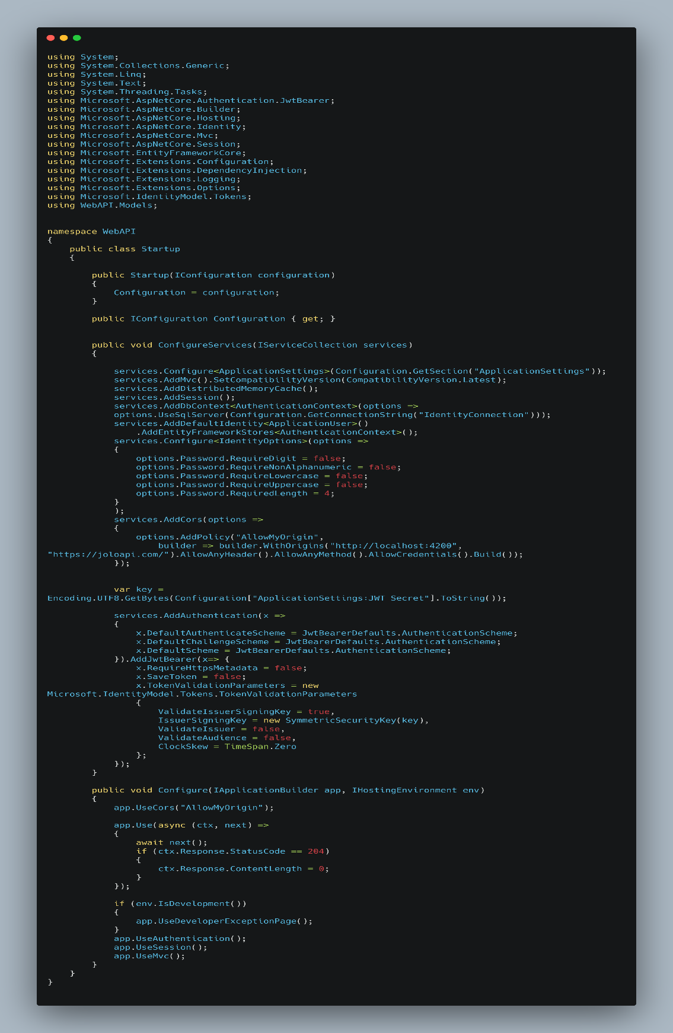

**PROJECT OUTPUT SCREENSHOTS**

**HOME PAGE**

**Screenshot 1.1** Welcome to Rpay

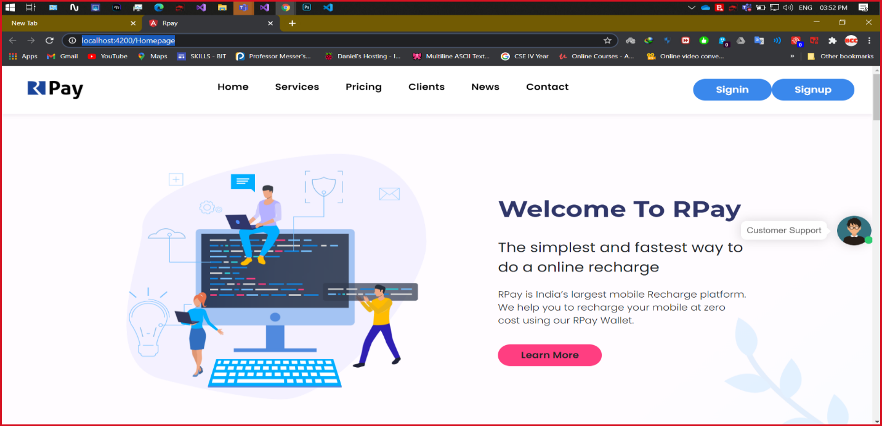

**Screenshot 1.2** Our Salient Features

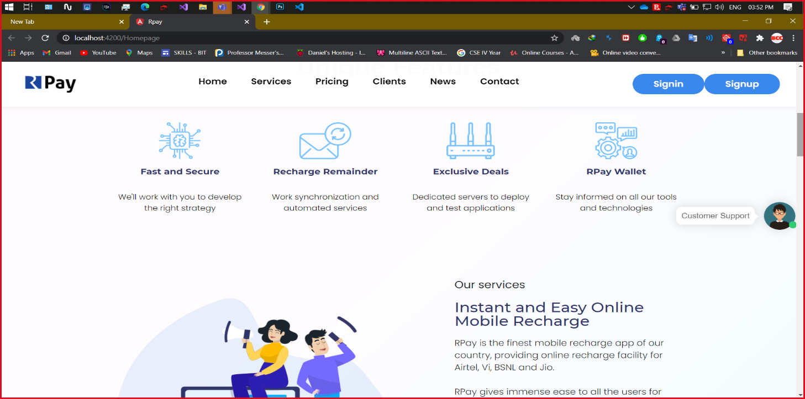

**Screenshot 1.3** Customer Reviews

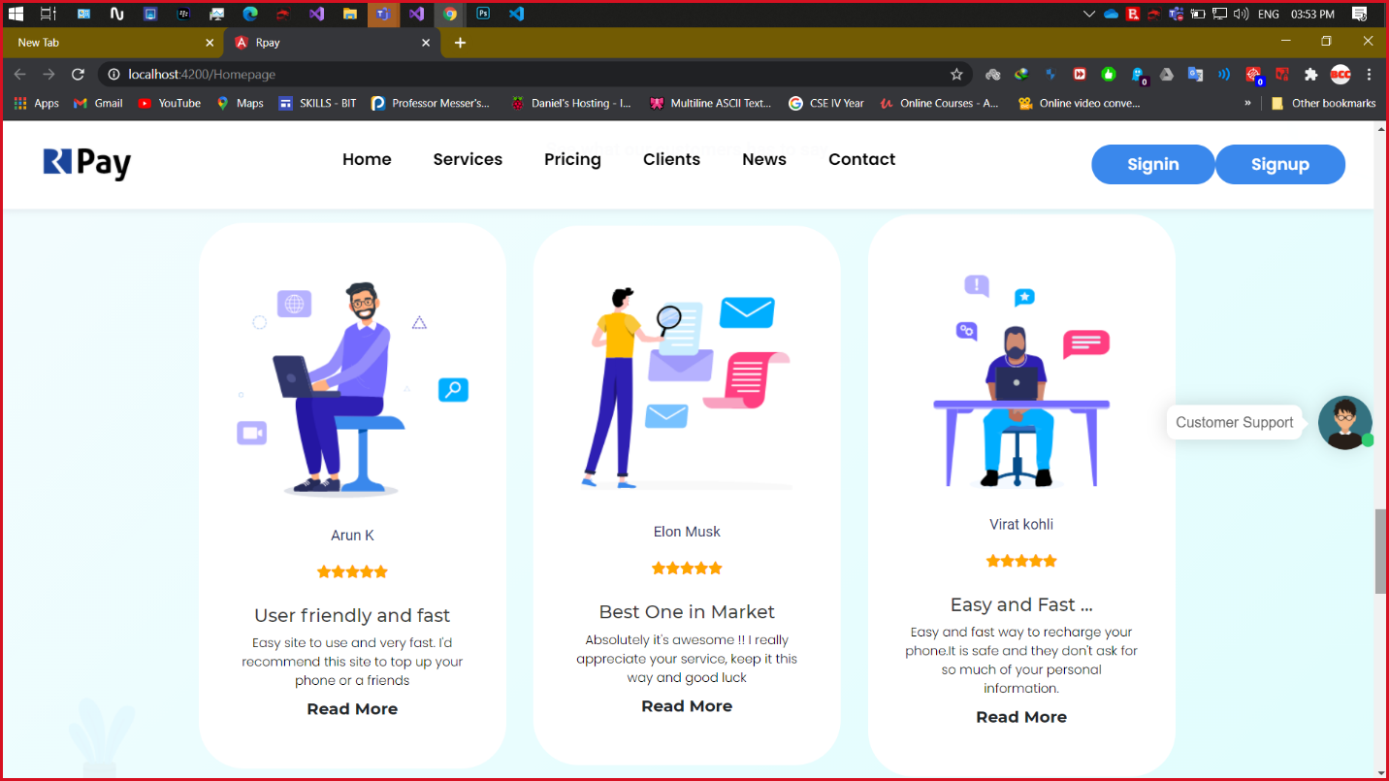

**Screenshot 1.4** Cashback Offers

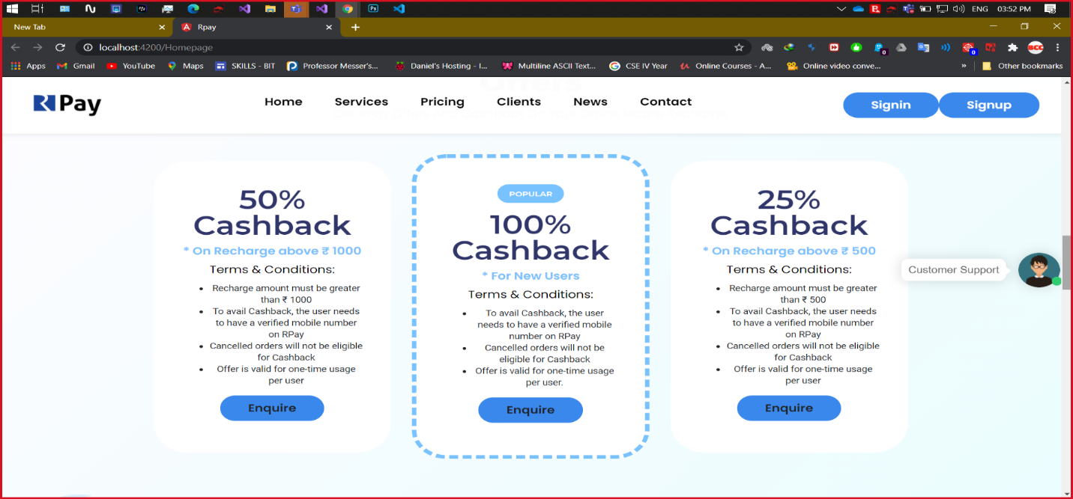

**SIGN UP**

**Screenshot 2.1** SignUp

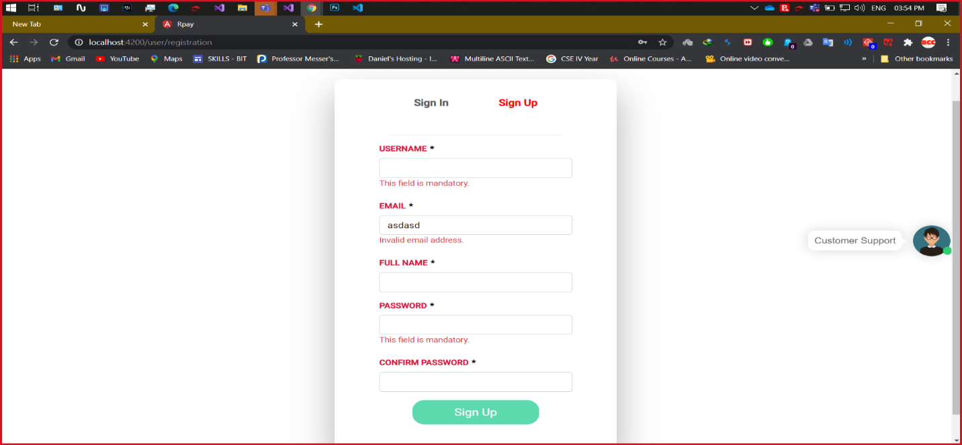

**SIGN IN**

**Screenshot 3.1** Sign In

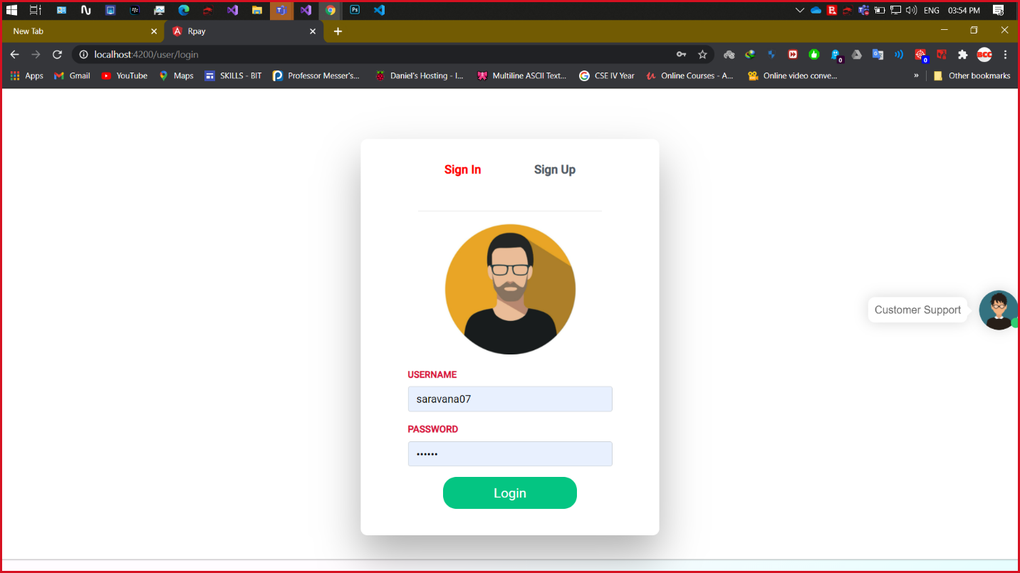

**Screenshot 3.2** SignIn with Invalid credentials

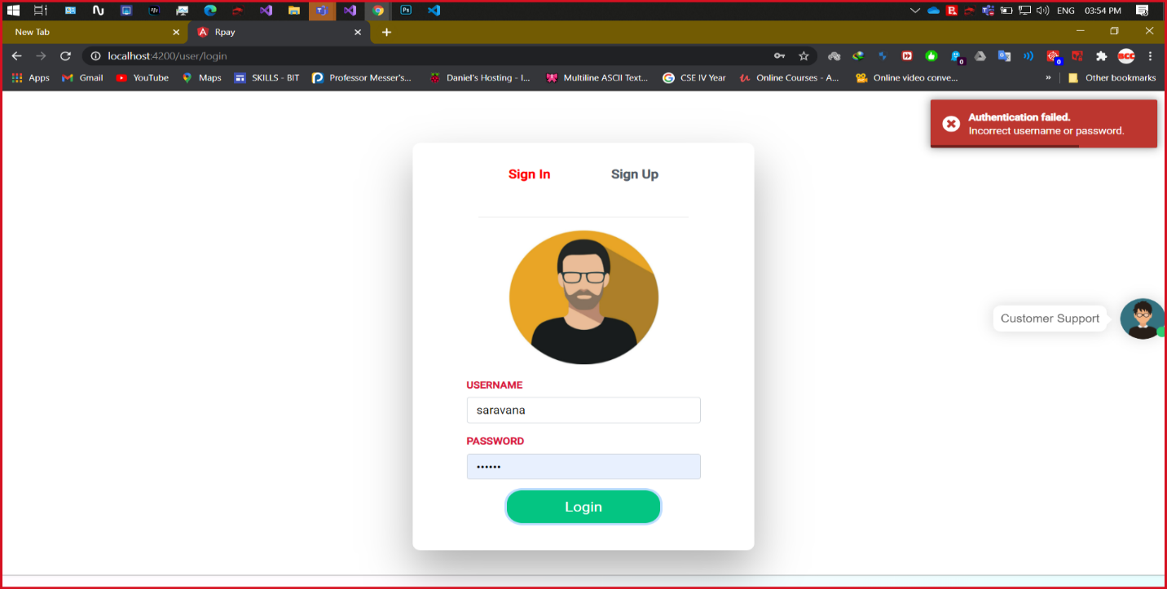

**RECHARGE**

**Screenshot 4.1** User Mobile Number & Operator

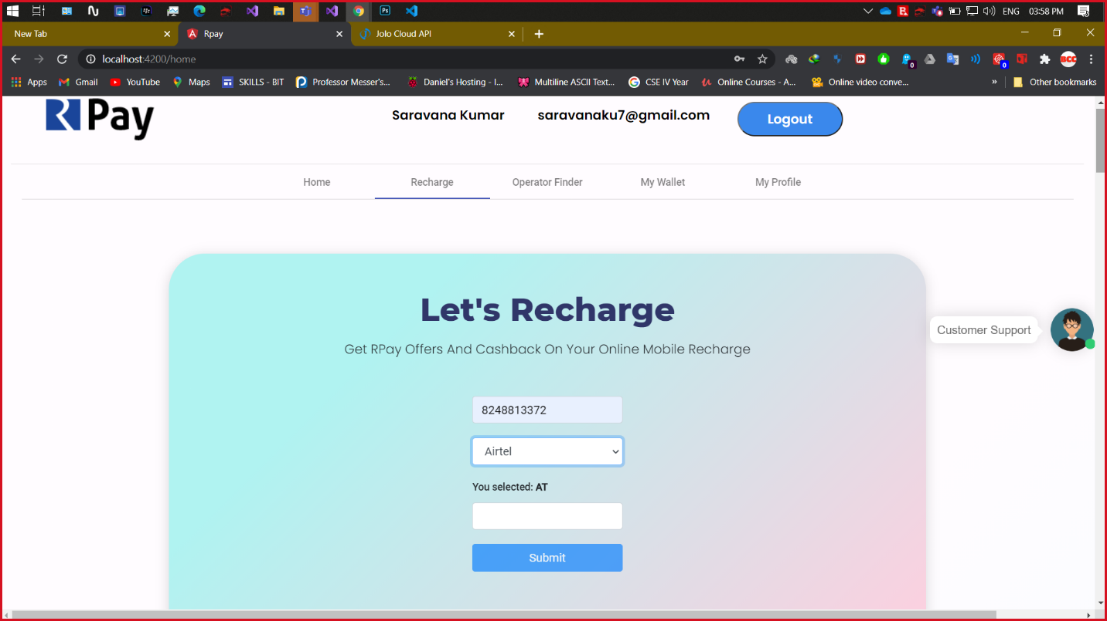

**Screenshot 4.2** Plan amount

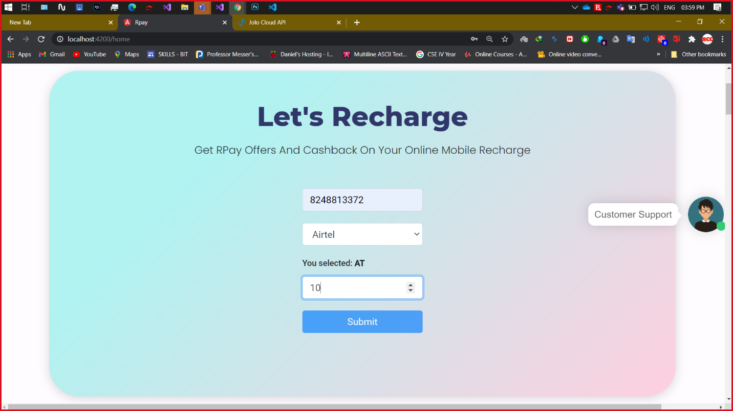

**Screenshot 4.3** Tarrif Plans

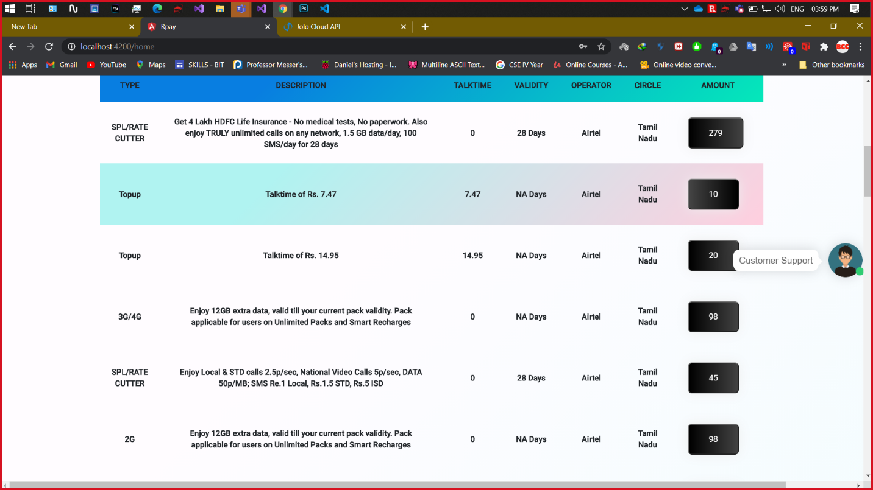

**Screenshot 4.4** Recharge Success

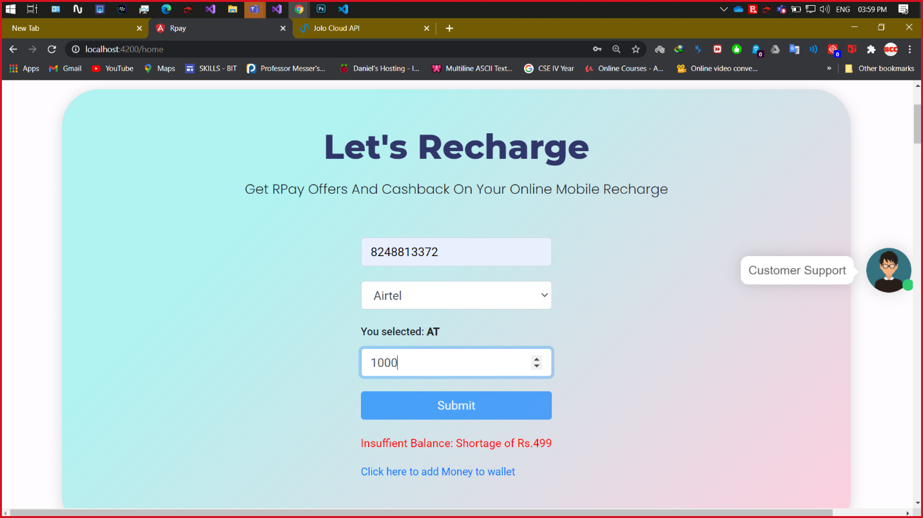

**Screenshot 4.5** Recharge Success SMS

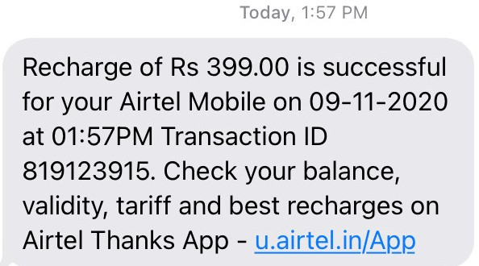

**ADD MONEY TO WALLET**

**Screenshot 5.1** Current Wallet balance

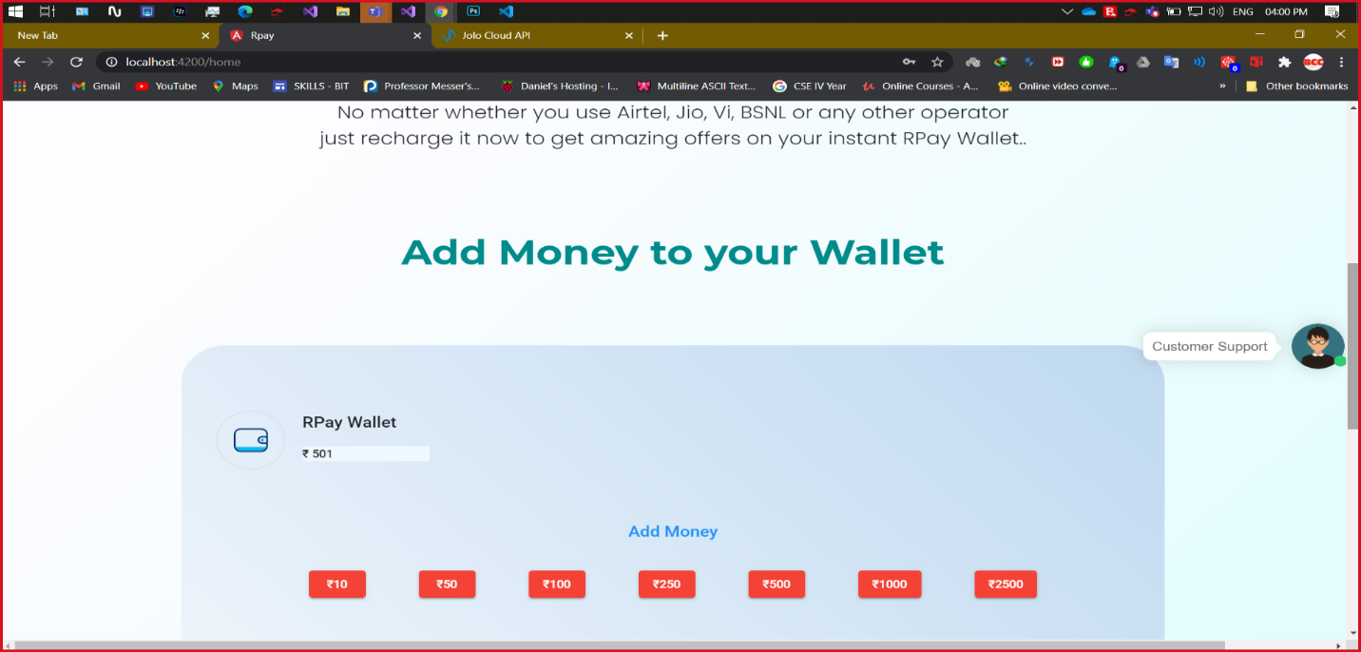

**Screenshot 5.2** Wallet History

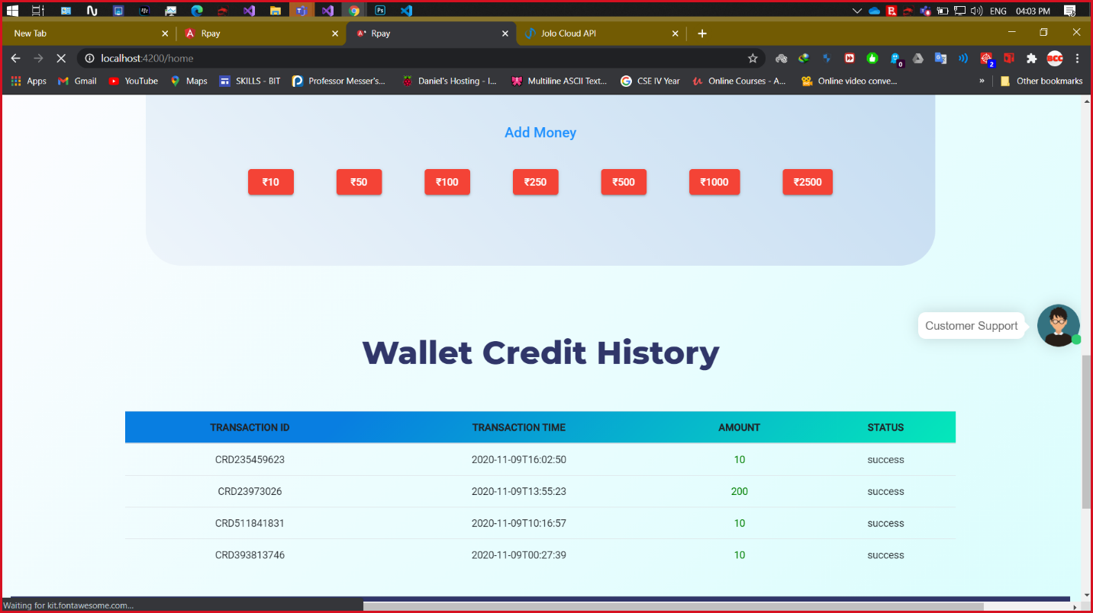

**Screenshot 5.3** Razor Pay Payment Gateway

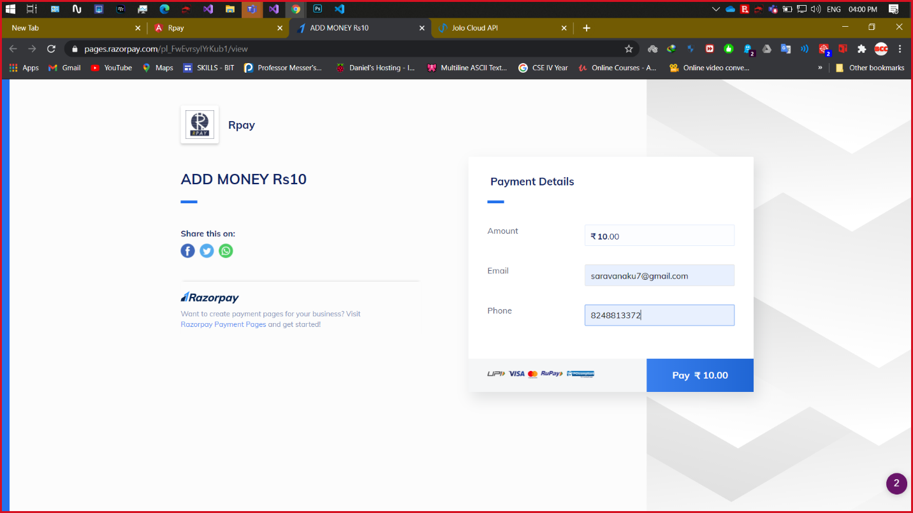

**Screenshot 5.4** Add Money – Bank details Verification

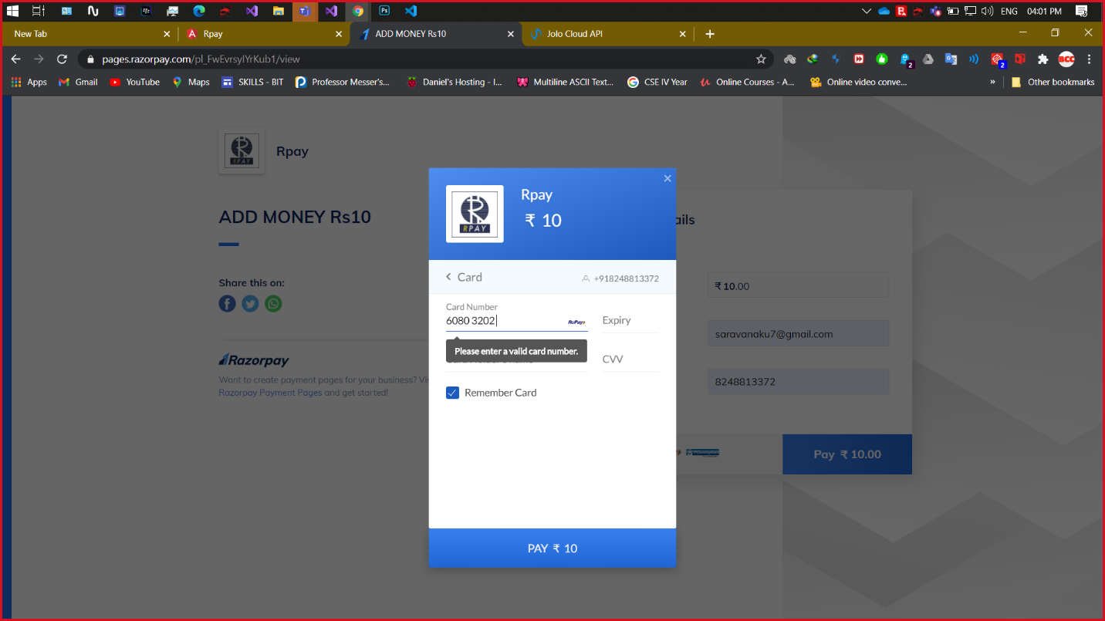

**Screenshot 5.5** Add Money – OTP Verification

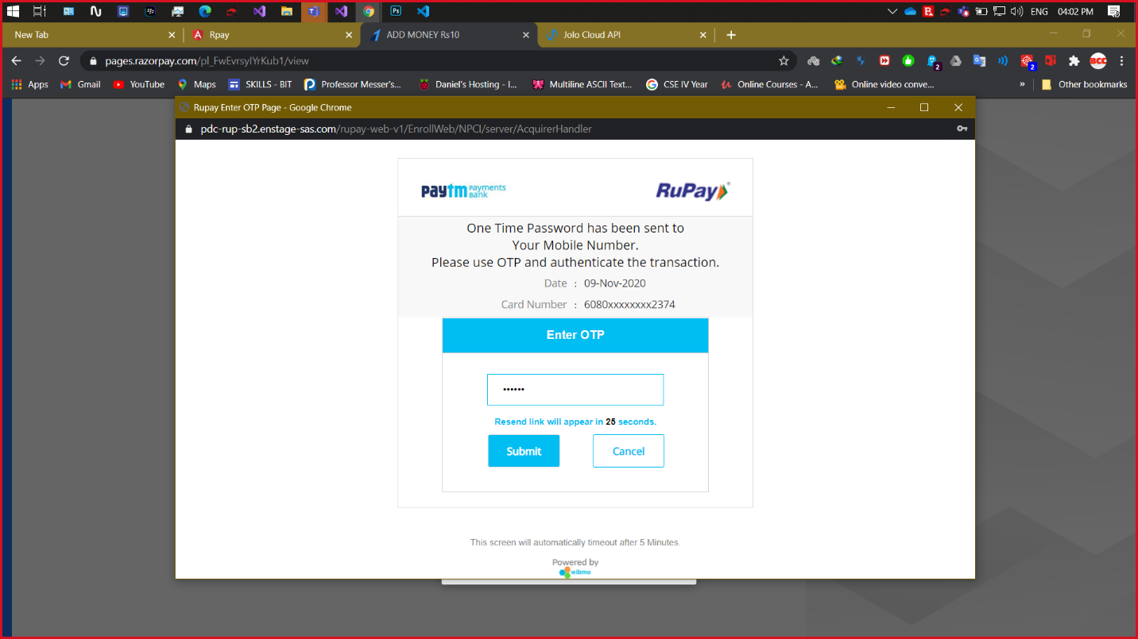

**Screenshot 5.6** Receipt for Added Money

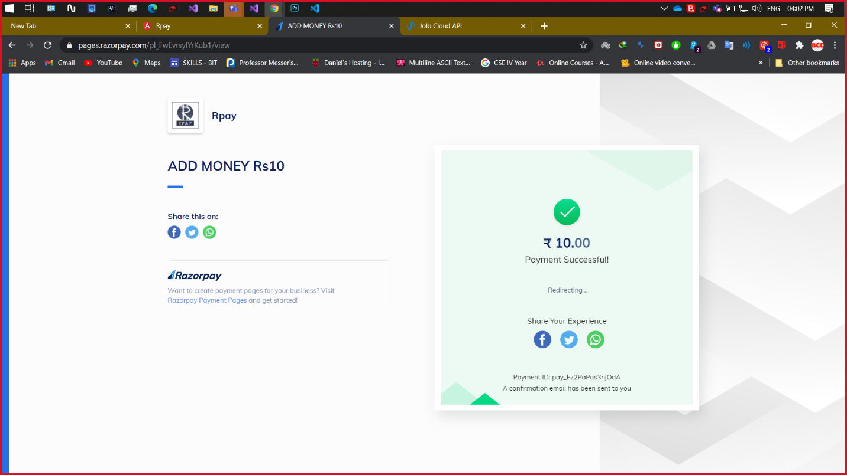

**OPERATOR FINDER**

**Screenshot 6.1** Operator name

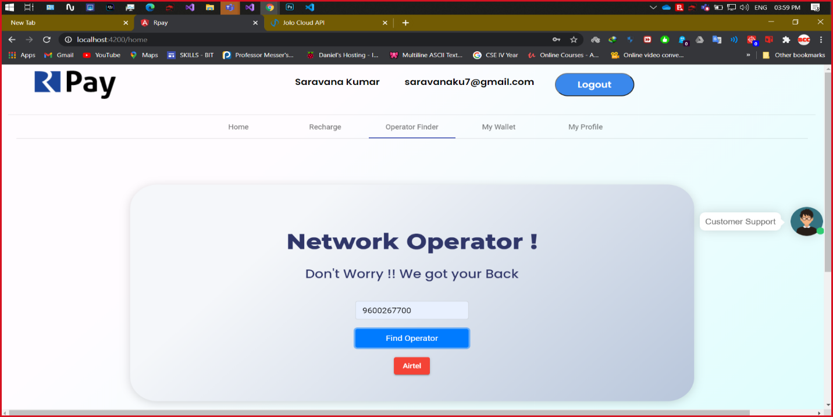

**MY PROFILE**

**Screenshot 7.1** Current Profile details

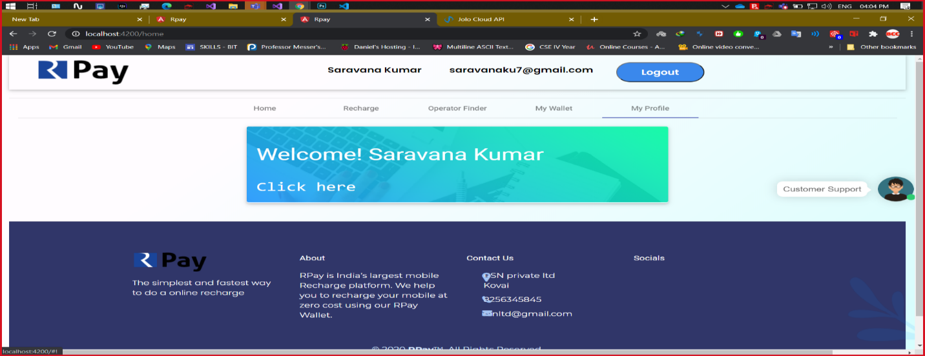

**Screenshot 7.2** Update Profile

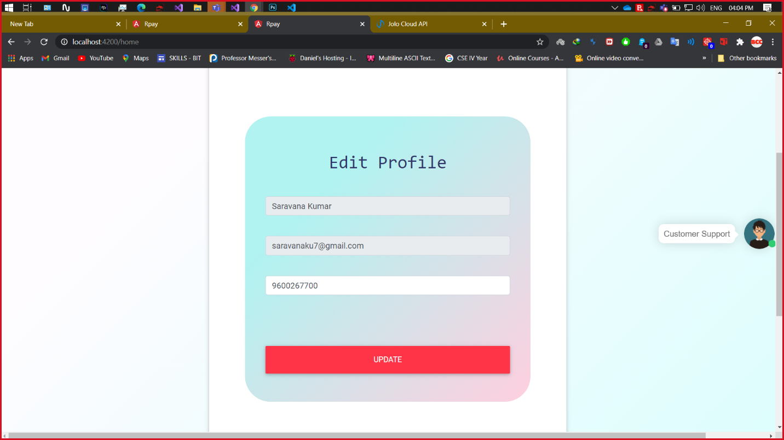

**CHAT BOT**

**Screenshot 8.1** Chatbot

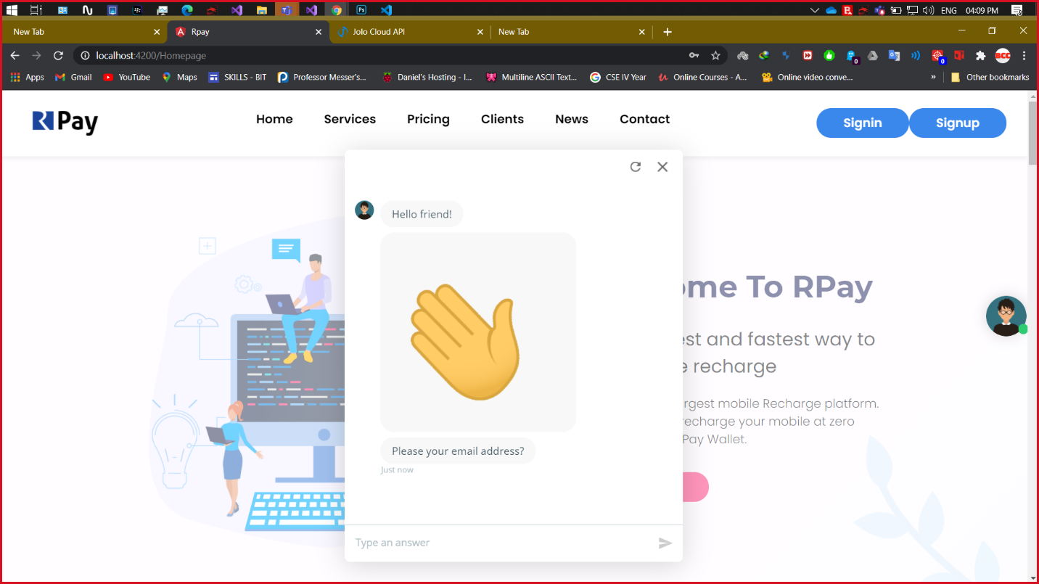

**Screenshot 8.2** Chatbot Query & Response

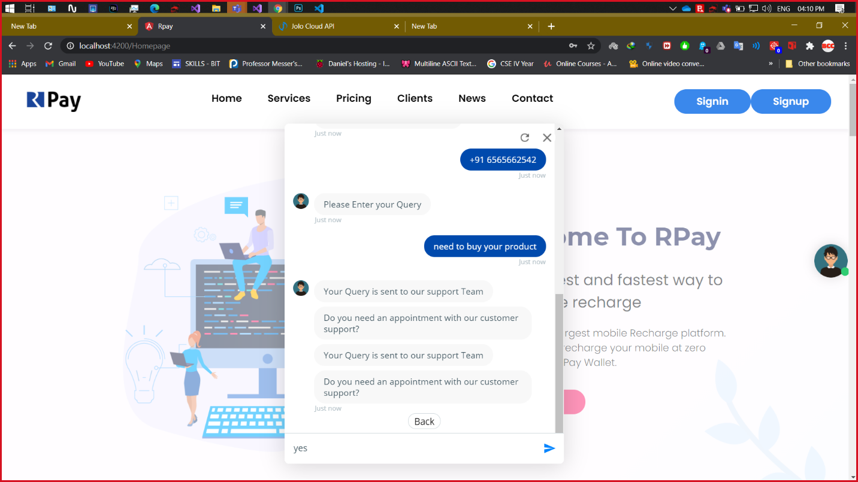

**Screenshot 8.3** Chatbot Mail Response

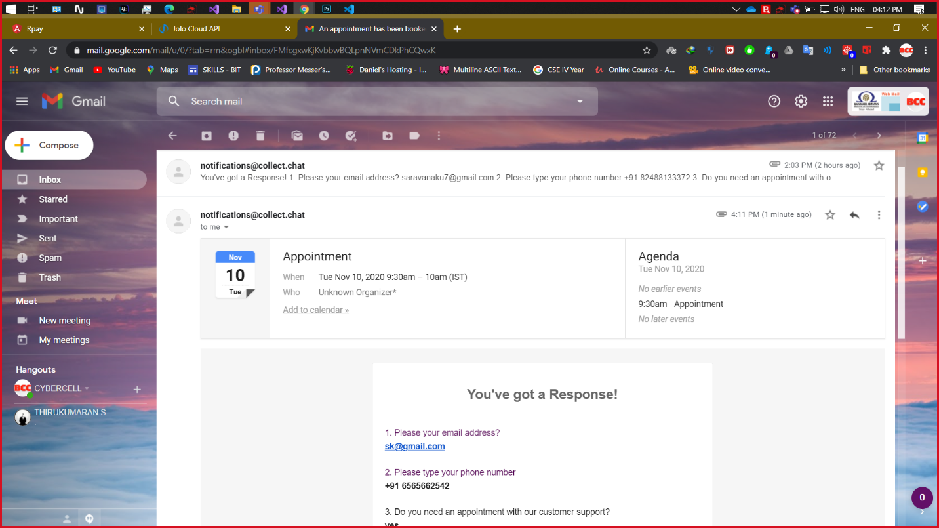

**RAZOR PAY DASHBOARD**

**Screenshot 9.1** Razor pay Home

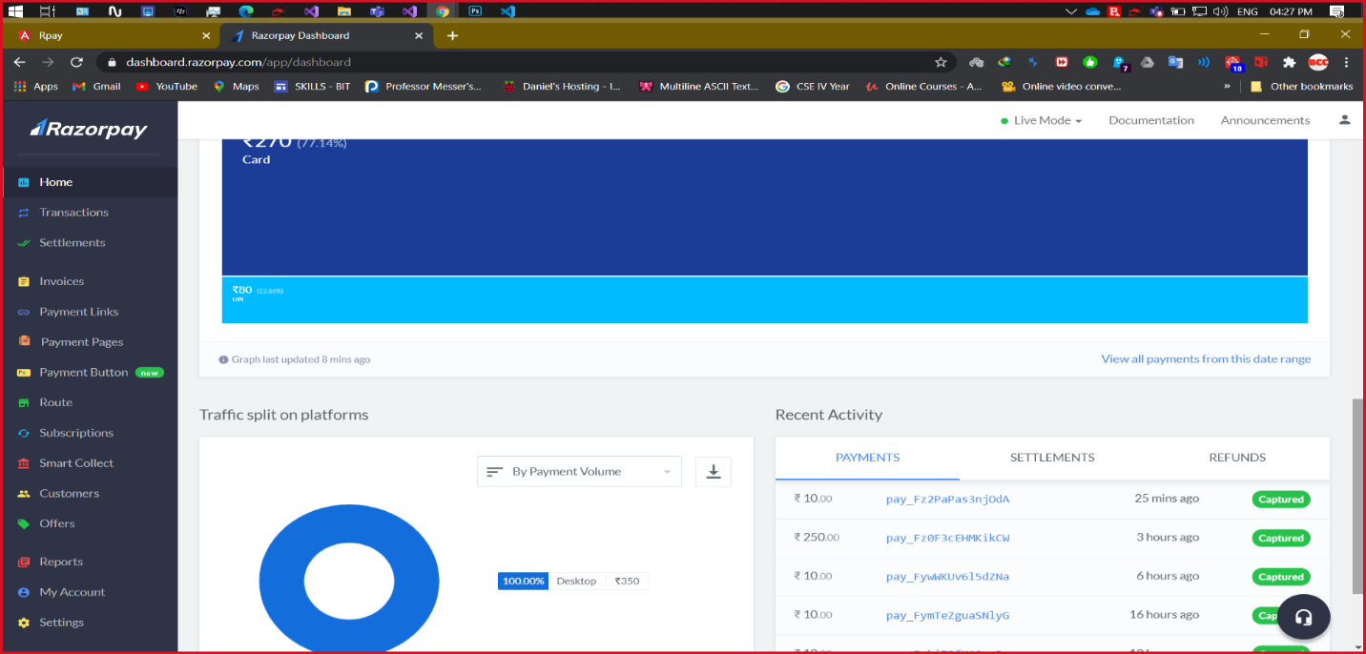

**Screenshot 9.2** Payment Monitoring section

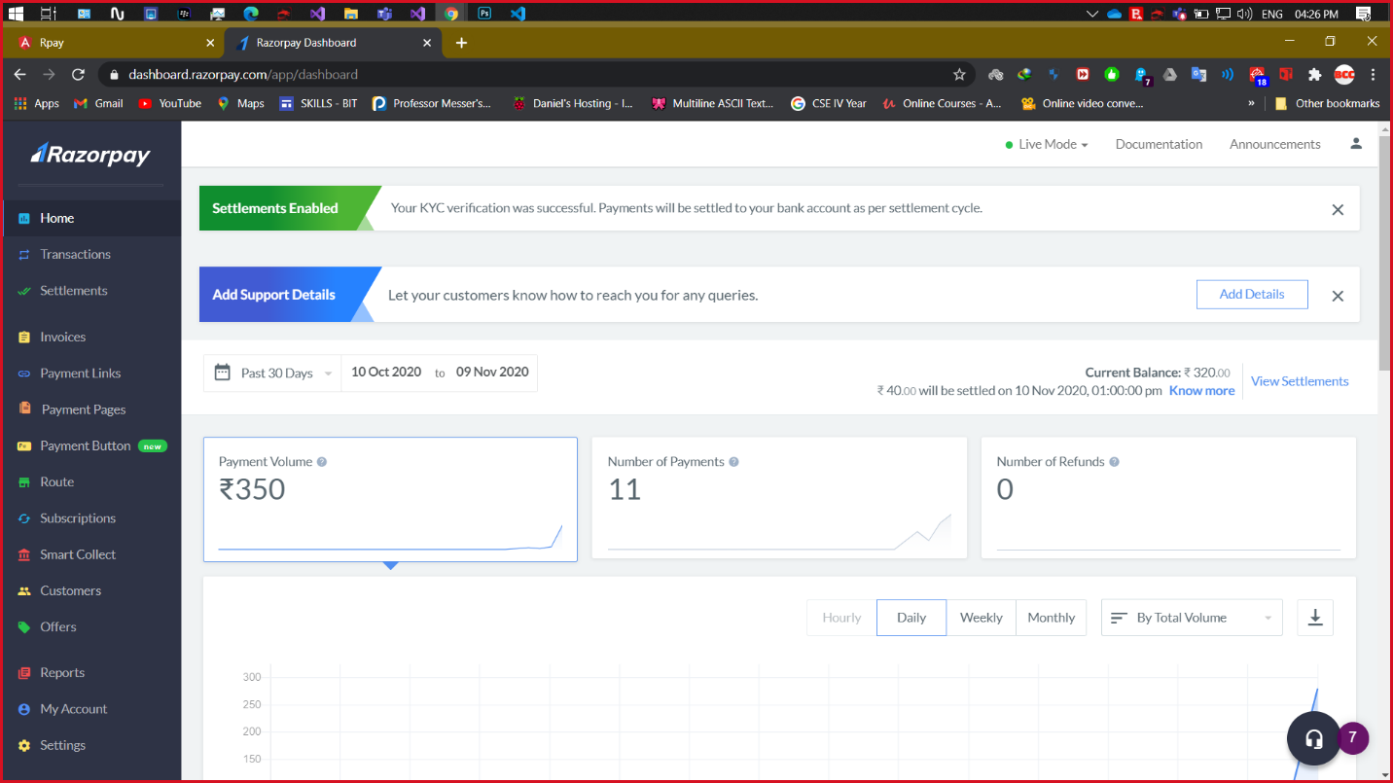

**JOLO API DASHBOARD**

**Screenshot 10.1** Jolo API Home

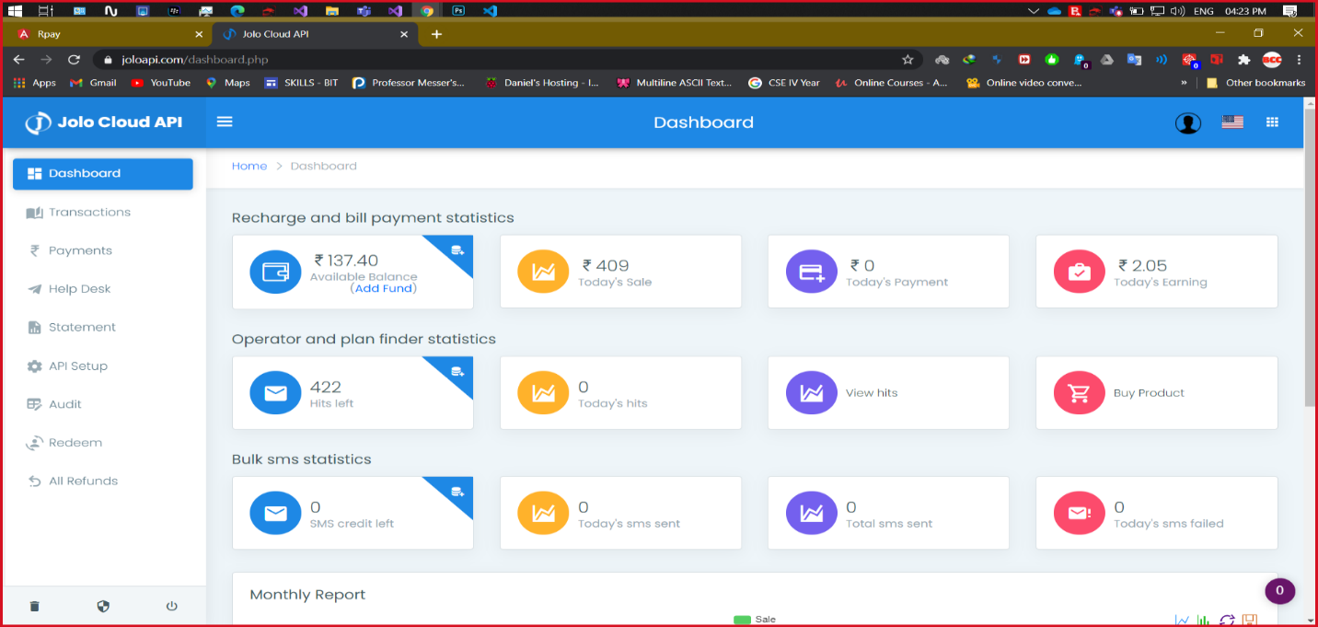

**Screenshot 10.2** Transaction Monitoring Section

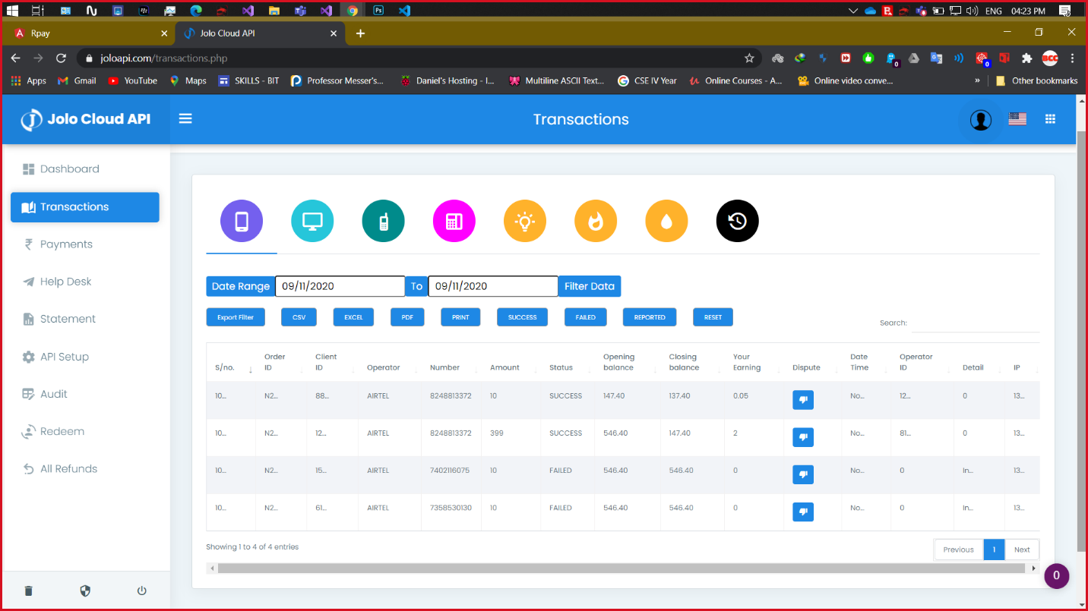

**Screenshot 10.3** Transaction AutoGenerated PDF

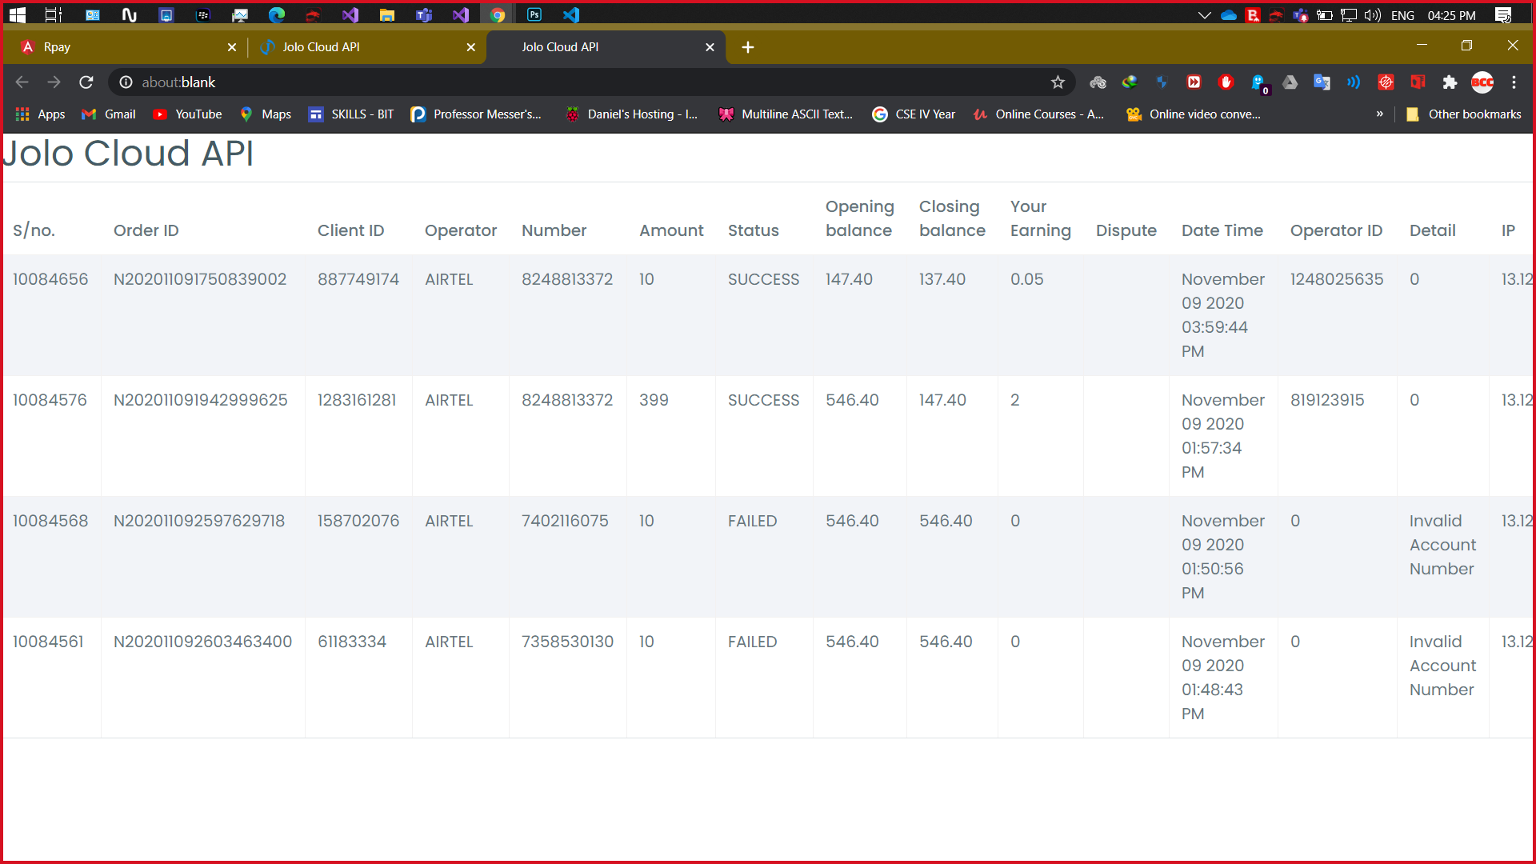

**ROLES AND RESPONSIBILITIES**

**SCREENSHOT WISE:**

|  |  |  |  |
| --- | --- | --- | --- |
| **Screenshot No** | **Page Name** | **Frontend** | **Backend** |
| 1 | Home Page | Naveeth | Rajagurunathan |
| 2 | Sign Up | Saravanakumar | Rajagurunathan |
| 3 | Sign In | Rajagurunathan | Saravanakumar |
| 4 | Recharge | Naveeth | Saravanakumar, Rajagurunathan |
| 5 | Add Money to wallet | Naveeth | Saravanakumar, Rajagurunathan |
| 6 | Operator Finder | Naveeth | Rajagurunathan,  Saravanakumar |
| 7 | My Profile | Naveeth | Naveeth |
| 8 | Chat Bot Integration | Naveeth, Rajagurunathan, Saravanakumar | |
| 9 | Razor Pay Integration | Naveeth, Rajagurunathan, Saravanakumar | |
| 10 | Jolo API Integration | Naveeth, Rajagurunathan, Saravanakumar | |
| 11 | Database Management | Rajagurunathan | |
| 12 | Database Hosting | Saravanakumar | |
| 13 | Web Api Hosting | Saravanakumar | |

**MODULE WISE:**

**1) Member Name: Naveeth Z A**

* Home Page - Front End
* Recharge - Front End
* Operator Finder - Front End
* My Profile - Front End & Back End
* Add Money to wallet - Front End
* Razor Pay Integration
* Chat Bot Integration
* Jolo API Integration
* Dry Run
* Integration

**2) Member Name: Rajagurunathan Manikandan**

**(Team Leader)**

* Home Page –Back End
* Recharge - Back End
* Operator Finder – Back End
* Sign In – Front End
* Sign Up – Back End
* Add Money to wallet - Back End
* Razor Pay Integration
* Chat Bot Integration
* Jolo API Integration
* Database and Query Management
* Integration

**3) Member Name: Saravanakumar Balasubramaniyam**

* Recharge - Back End
* Operator Finder – Back End
* Sign In – Back End
* Sign Up – Front End
* Add Money to wallet - Back End
* Razor Pay Integration
* Chat Bot Integration
* Jolo API Integration
* Integration
* State Management using JWT
* Online Database Hosting
* Web Hosting